The inspiration for this system comes from watching the MS 08 Team series. There was something so evocative about Mobile Suits fighting it out in the Jungles of Southeast Asia. It was more gritty and inspirational than the usual ‘space-opera’ that has been presented in other Gundam series. The Battle System therefore reflects the claustophobic down to earth Mobile suit actions that took part on Earth during the One Year War of UC079 and its immediate aftermath.

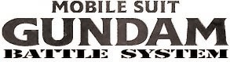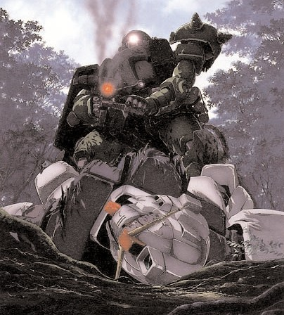

Now you can command your own teams of Mobile Suits in battle. You can choose your side, take command of a beleaguered Federation Mobile team or the Zeon Expeditionary forces - with their powerful Zaku’s, Doms and Magella Attack Tanks.

## What You Need

Alongside this rule book, each player will need several 6 sided dice, a Warhammer 40,000 Scatter die and a ruler or tape measure in inches. Each player should also have a written copy of their army, detailing suits, upgrades and any experience earned. Extra paper and pens are highly recommended for record keeping during the game.

Each player must provide a complement of 1/144 scale miniatures to represent their forces, as well as miniatures or other materials for battlefield cover and terrain. The book generally assumes the use of Bandai's High Grade Universal Century line of miniatures, though players should not feel limited to just these. Similar scale action figures would also be appropriate.

## A Brief Introduction

Welcome to the Mobile Suit Gundam Battle System, an exciting miniatures game for 2 or more players in which they can act out the battles of the One Year War from the Anime Mobile Suit Gundam. Each player commands a team of bipedal armored vehicles, called mobile suits fighting to complete various objectives on the game board.

The most important item for any game however is a good attitiude and sense of fair play. At the end of the day, we are all living out our fantasies of piloting giant robots with plastic models.

The Mobile Suit Gundam Battle System rulebook is designed to be fully self cotained. It includes the full rules for playing the game as well as army lists for both the Earth Federation and Principality of Zeon.

## Dice Rolls

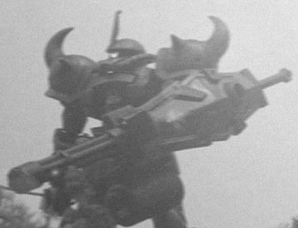

In addition to normal rolls of 1 d6 die, the game often requires multiple combinations and variations. For instance when 2 dice must be rolled, the game will denote it as 2D6. If additional modifications are required, they will be denoted with a +X or -X after the D6. In that situation, one must add or subtract from the total based on the modifier given. Modifiers often come about in the game as penalites or rewards. These will ALWAYS stack outside of categories. For instance, if a suit is both running and obstructed from view, an opponent would combine the penalties for movement and cover. They would not, however, combine the penalties for walking and running.

*Good luck Pilots, check your weapons and stay sharp. You are ready to start fighting in the world of Gundams. Be sure to check out the Federation MS team list and Zeon Expedition lists for your Suit specs and your pilots abilities, use your forces wisely Commander. That is all…*

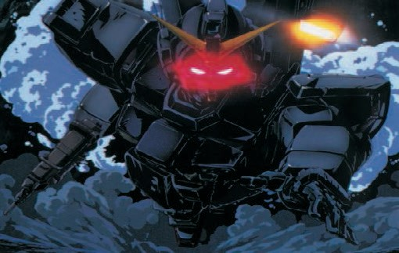

## Characteristics

There are 8 characteristics used to describe a pilot and his mobile suit. They tell them player how well he can fight and shoot, how much brute strength his suit possesses and even how likely he is to break and run in combat.

|  |  |  |  |  |  |
| --- | --- | --- | --- | --- | --- |
| Mobile Suit | **WS BS S** | **W I** | **A** | **PS LD** | |
| Pilot Bonus | - - 5 | - - | - | - - | |
| **Armor Values**  Zaku I | **Front**  12 | **Side**  10 |  | **Rear**  10 | **PV**  80 |
| **Unit Types** |  |  |  |  |  |

#### Pilot Skill

Pilot skill represents the average piloting ability of the MS operator and several times during the game he may be called upon to make a roll against his Piloting Skill. To do this roll 2D6 you pass if you score under or equal to your PS total, you fail if your score above it

#### Pilot Characteristics vs Suit Characteristics

Most characteristics are inherent to the pilot and his training. This is represented by the pilot's stat line, found in the army list. A mobile suit can improve elements of a pilots stat line as well, represented by a +X found in the mobile suit's entry in the Hangar. The exception to Strength (S), which replaces the pilot's value.

Below is a sample profile for a pilot and a mobile suit. Pilot

|  |  |  |
| --- | --- | --- |
|  | **WS BS S W I** | **A PS LD PV** |
| Veteran Pilot | 4 4 3 1 3 | 2 8 7 25 |

#### Weapon Skill

Weapon skill is a measure of a pilot's abilities in close combat and how likely they are to strike their opponents.

#### Ballistic Skill

Ballistic skill measures a pilot's ability to fire ranged weapons and affects how likely they are to score hits with machine guns, missile launcher and beam weaponry carried by their mobile suit.

#### Strength

Strength is a measure of the raw power of a suit. This affects its ability to penetrate thick armor when in close contact.

#### Wounds

Wounds represent a pilot's ability to mitigate damage to their suit beyond normal damage rolls

#### Initiative

Initiative represents a pilot's reflexes and ability to react to incoming attacks. The higher the value, the more liklely a pilot's chances of dodging incoming fire.

#### Attack

Attacks represents the number of times a suit may strike its oppoenent when locked in close combat.

#### Leadership

Leadership represents the grit and will of a pilot under extreme circumstances. The higher a leadership score, the more likely they are to resist the urge to flee the battlefield.

There are two types of units in MSGBS: Mobile Suits and Vehicles

#### Mobile Suits

Mobile Suits are humanoid combat vehicles, typically employing two arms to deploy weapons, two legs for propulsion, and a head that acts as a main camera and sometimes houses a secondary weapon that acts as a rotating turret (with the head itself providing the rotation). Typically speaking, a mobile suit is approximately 60 feet in height, with a cockpit located in the unit's torso.

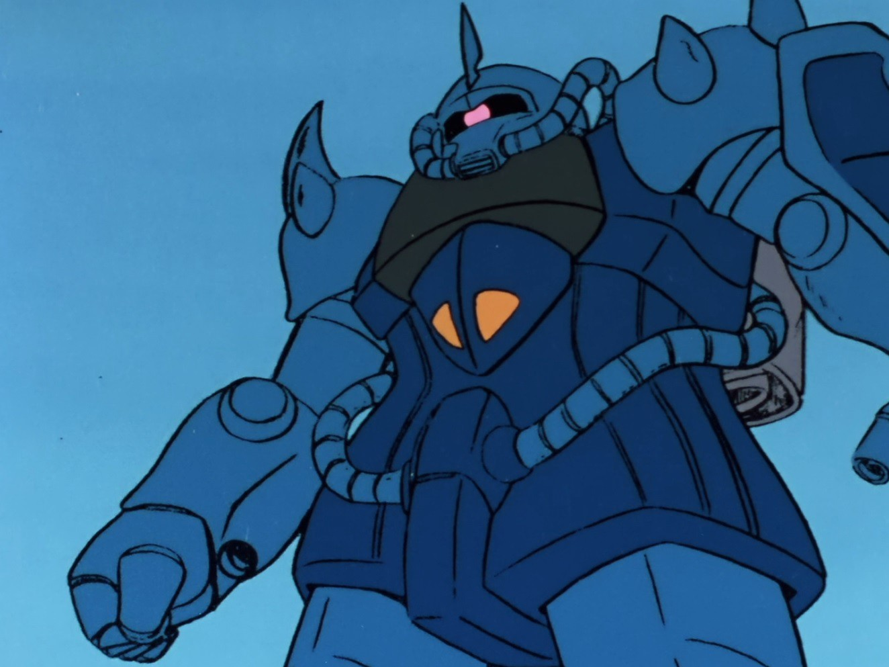

#### Vehicles

Vehicles run the gamut from Federation Hover Trucks to Zeon Magella Attack Tanks. Outclassed by mobile suits, many vehicles have been reduced to a support or ambush role in Federation and Zeon Ground Forces.

## Leadership Tests

Units in MSGBS will often be called upon to make a test of their resolve, called a Leadership test. The player rolls 2D6 and compares the score to the Pilot's Leadership Score. If the score is equal to or less than the Leadership Score, the pilot passes the test. Otherwise, they fail he test.

#### Failing Leadership tests

If a pilot fails the Leadership test, it falls back 2D6" towards its own table edge each movement phase until it passes its leadership test. It may continue to shoot as usual. Units may not initiate assaults, but may react to them as normal.

Units may regroup as long as no enemy units are within 6". The unit takes another leadership test and, if it passes, may act as normal. It may not move and counts as having moved for the purposes of shooting and assaulting. This process is repeated until the unit passes the Leadership Test or crosses its own table edge. In this case the unit is removed from play and counts as destroyed for calculating victory points

# The Turn

Turns in MSGBS are divided into three phases: Movement, Shooting and Assault. Each player is given an opportunity to move shoot and assault, one after the other. The order is determined by the roll of a d6. Each player rolls one dice and the highest number has the opportunity to choose to go first or second.

A turn encompasses three phases for each player: Movement, Shooting and Assault. After each player has completed al the phases, the game moves to the next turn and all the actions are repeated. Games of MSGBS typically last 6 turns unless otherwise specified by game specific special rules.

#### Movement

The player may move any suits or vehicles that are capable of moving.

#### Shooting

The player may choose to fire the weapons of some or all of his mobile suits and vehicles

#### Assault

The player may nominate units to charge into the melee and resolve those close combat actions.

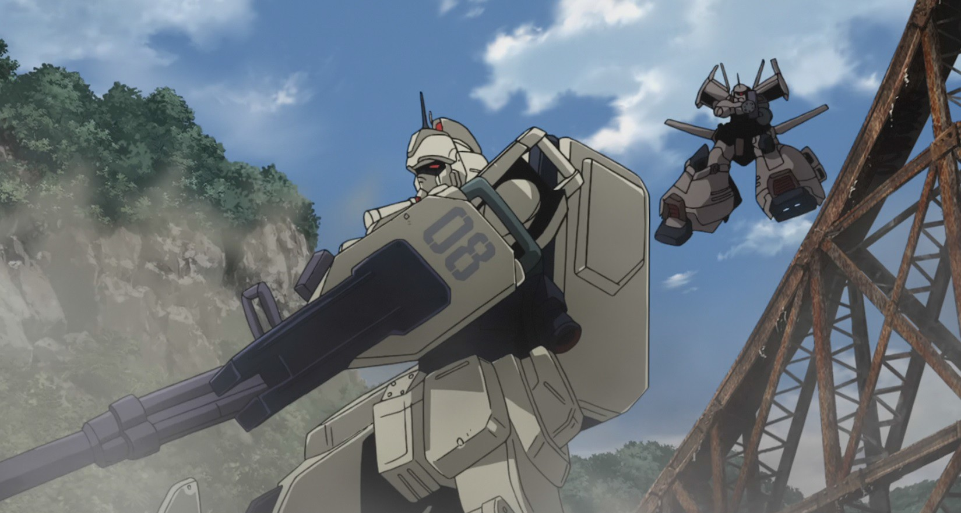

# The Movement Phase

Most Mobile suits can move up to 6” at a walking pace in the movement phase. This represents a cross-country combat speed rather than flat out. Also most Mobile suits can run up 9” but this affects targeting for both you and the enemy targeting you. Some suits have the option to be equipped with jetpacks allowing them to jump up to 12” in any direction.

Running speed 9”

Difficult terrain speed D6”

**Mobile Suit Movement Chart**

Walking speed 6"

Jump pack speed

12"

All Mobile suits can move an additional 6” in the assault phase if they are within 6” of an enemy Mobile Suit. This represents the pilot charging into action and he gains additional attack bonus for this. Mobile suits equipped with a jump pack may move at a maximum of 9" in the assault phase.

Vehicles can move up to 8" at a cross country speed. They may need to move slower in order to fire their full complement of weapons

|  |  |  |
| --- | --- | --- |
| **Vehicle Movement Chart**  Cross Country 8" | | |
|  | Difficult terrain speed D6” |  |

To represent this a Mobile Suit that moves through difficult ground must roll a D6 and move the amount of inches scored on the roll. On a roll of a one the Mobile suit becomes stuck and cannot move unless a 4+ is rolled in the pilots next turn.

A Mobile suit if equipped with a jetpack can use it to enter or leave difficult ground. Both require a Pilot Skill roll to be made. If failed the suit counts as stunned next turn. If a double six is rolled the suit leg actuators are too badly damaged by the landing and the suit counts as immobilized for the rest of the game.

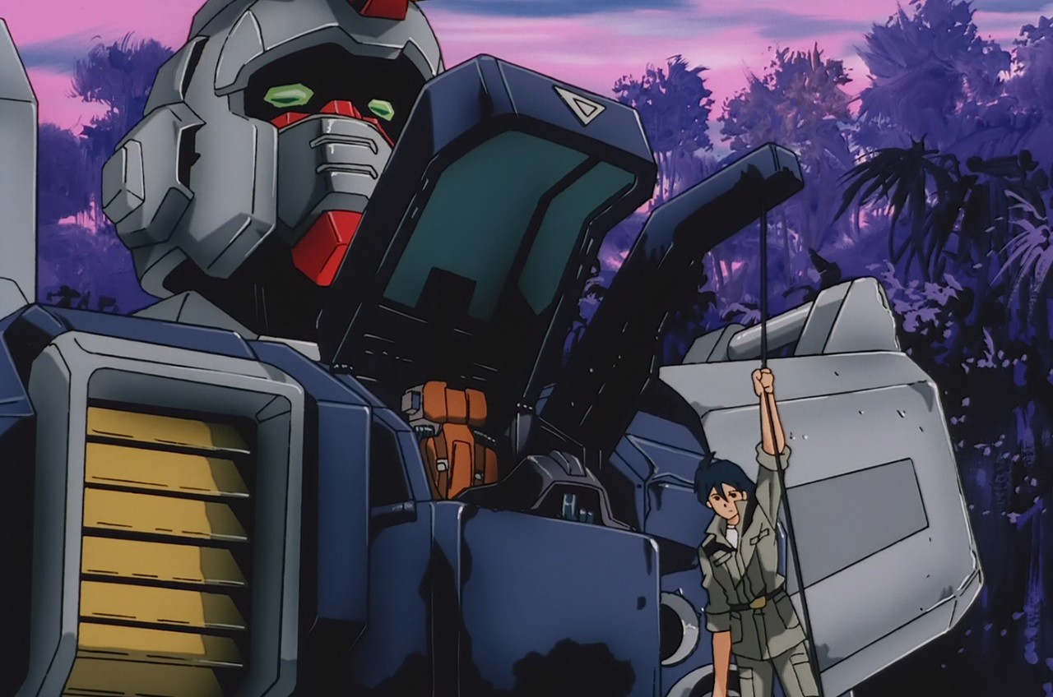

#### Terrain

There are 4 types of terrain: clear, difficult, roads and impassible

#### Clear

Clear terrain covers most of the board and causes no penalities to movement

#### Difficult

Difficult terrain slows movement of any units moving though it

#### Roads

Roads facilitate the movement of non-mobile suit units, enabling them to move more quickly throughout the battlefield.

#### Impassable

Impassable terrain prevents all movement through it

#### Vehicle Movement Terrain Effects

Vehicles must make the a roll when entering or leaving difficult terrain. The player must roll a D6 for movement, just as with Mobile Suits, but on a roll of 1, the vehicle is immobilized. In this instance, it is unable to move for the remainder of the game. It may continue to take other actions as normal. If a vehicle fails a leadership test and would normally be required to fall back, it is instead abandoned and considered destroyed for the remainder of the game.

Vehicles that travel on road terrain for their entire movement may add 4" to their total move distance. This does not apply if the vehicle shoots or takes a difficult terrain test at any point in its movement phase that turn.

#### Mobile Suit Terrain Effects

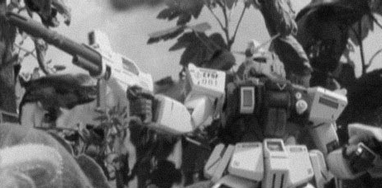

Mobile Suits are all-terrain attack vehicles and can move through most terrain with ease. However if moving through woodland, rocky buildings, broken ground or water the Pilot must take care or he might damage or even immobilize his suit. Vehicles also face challenges in difficult .

# The Shooting Phase

#### The Shooting Process

**1. Choose a target:** Select an enemy unit for one your units to fire at. You must pass a leadership test if you wish to shoot at an enemy besides the closest enemy unit

1. **Check line of sight and range:** See if the target is within sight and range of your firing unit. Despite the interference of Minovsky Particles, Mobile Suits and Vehicles posses high powered cameras, enabling them to accurately judge distances. The player may pre-measure all hooting distances prior to committing to a ranged attack and may change targets should a target be out of range.
2. **Roll to hit:** Roll a D6 for each shot fired by the unit. and consult the Ballistic Score To Hit chart to determine if each shot hits. Each type of weapon should be rolled separately.

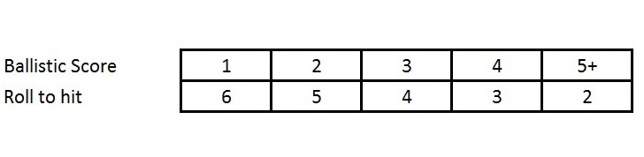

1. **Consult damage charts:** Consult the damage charts for the mobile suit or vehicle. First, determine armor penetration then consult the approriate damage chart. Damage charts are divided between Vehicles and Mobile Suits, with each possessing separate sections for glancing, penetrating or ordinance penetrating hits. A glancing hit is a any hit whose strength exactly matches the targeted armor value. Penetrating hits are any hits which exceed the armor value. Ordinance weapons a large, high powered weapons which make use of the large blast template. This characteristic is noteed

in the weapon's profile

**5. Make Wound Rolls:** Take saving wound rolls armor saves and

other damage mitigation attemps as necessary.

**6.Make Leadership Tests if applicable:** Any unit which suffers a

penetrating or glacing hit must take a leadership tests. Penetrating hits add +1 to the dice roll.

**7. Choose another target:** Continue selecting targets until all units

that may shoot that the player wishes have fired.

#### Mobile Suits, Movement, Shooting

Mobile suits are capable of moving and shooting at the same time. Unless they using a heavy or ordinance weapon which they must remain still to shoot, the represents the suit bracing against the weapons recoil. If you are moving at the firing at the same time this effects targeting due the suit jolting – the faster you go the harder it becomes to target your enemy. Of course this works the other way too the faster you go the harder it is for your enemies targeting system to get a lock on you.

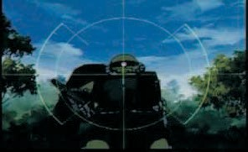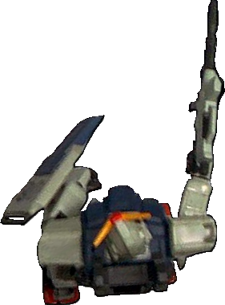

**FIRE ARC**

**BLIND SPOT**

Mobile Suits must fire their weapons against one target, and cannot unless specified by the Suit specs pick out multiple targets. In addition if the Suit is moving the Pilot can only activate and use one weapons system at a time, unless of course they remain still then they can use up to two different weapons systems. It is also important to remember that Mobile Suits have a 270 degree fire arc but cannot fire at targets behind them.

#### Line of Sight

When checking to see whether a unit is within line of sight, the player must be able to look from the shooting unit's perspective and see the target unit. If the target unit is 25% obscured, the shooting unit suffers a -1 on its To Hit roll. If the target is obscured up to 50%, the shooting unit suffers -2 on its To Hit roll.

Line of sight is determined from the head of a mobile suit as that is the location in which the primary cameras are located. Vehicles, due to their small size, do not draw line of sight from a particular point due to their small size and can draw line of sight from any point on the hull of the model. Barrels and weaponry do not count.

#### Shooting at Mobile Suits

A Mobile suit is a little harder to destroy than a normal foot soldier or even tank. They are heavily constructed with advanced alloys protecting their vital systems. Any hits that do penetrate might hit a none vital system or on the other hand it might hit the Mobile Suits reactor blowing it sky-high. Plus it doesn’t matter how tough a Mobile Suit is, the pilot inside can still be stunned or shaken by the concussion of the hits against its armored hide.

-1 if target is quartered covered

**Modifiers**

+1 if target/firer is stationary

-1 if target/firer is walking

-2 if target/firer is running or jumping

-2 if target is half covered.

For example: *A GM armed with a 100mm Machine gun is standing still trying to target a running Zaku in quartered cover. The pilots ballistic skill (BS) is 3 which looking at the to hit chart means he needs a 4 or more to hit. He rolls the two dice as indicated by the weapon type and scores a 5 and a 6, and then applies the modifiers. First a –2 for the running Zaku, then an addition –1 for the cover the Zaku is in taking his dice score down to 2 and 3 which means he has missed. However his GM was stationary to improve his targeting and his target was within half range of his weapon so he gains a +2 to his dice taken both his scores back to 4 and 5.* A DOUBLE HIT!

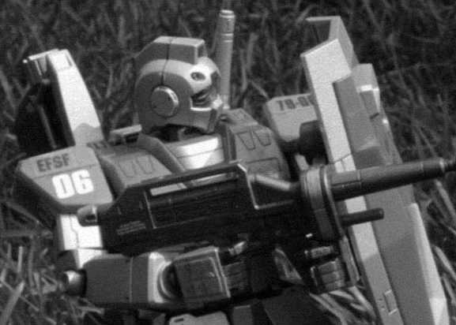

The Rule of One and Six

When firing work out if the weapon is in range, find the score you need to hit and roll a D6 then apply the following modifiers. If the modifiers take you below the to-hit score you fail to hit your target. If the modifiers take you above the to hit score then you hit. As long as you make the to hit roll you will hit your target. These modifiers are accumulative also don’t forget to check your weapons profile as they normal have a modifier to apply according the range to the target.

You may notice looking at the modifiers there are times when you won't be able to hit your target. Or that you BS skill of the pilot you’ve chosen makes it almost impossible to miss. This is where the rule of One and Six comes in, a roll of a One on a D6 always misses regardless of modification and roll of a Six always hits regardless of modification.

#### Shooting Phase Leadership Tests

Whenever pilots suffer major damage to their suits or vehicles, fear can easily take hold. To represent this, any time a pilot's suit or vehicle suffers a penetrating or glancing hit, they must take a leadership test. Penetrating hits, which cause even more damage force the pilot to add +1 to his leadership roll.

# The Assault Phase

The assault phase is divided into two sections: the charge and combat phases. In the charge phase, the player declares that a unit is charging before moving them into contact with their opponent. In the combat phase, the players fights close combat, determines damage to his and his opponents suits and takes any saves and morale checks as necessary.

attack for each point of their listed Attack value in their profile. Again, consult the Mobile Suit's profile dor any bonus.

For each attack, the player who controls the Mobile Suit consults the To Hit chart, comparing his Weapon Skill to that of his oponent. If he suceeds in his role, he rolls 1D6 and adds the Suit Strength and Close Combat Weapon Strength Bonus to determine armor penetration.

#### The Assault Process

1. **Choose a unit**

Select a unit which has not already made an assault and is capable of making an assault in that phase. Units that fired during the shooting phase may only assault their shooting phase target. Units which fired rapid fire weapons twice or remained stationary to fire heavy or ordinance weapons may not assault at all in the same turn.

#### Declare a charge with that unit

Choose a target within range of the assaulting unit and declare it that target of the assault

#### Determine Assault winner

If neither Mobile Suit has been destroyed in the resulting resulting combat, then the Mobile Suit that has scored the largest number of hits will win the combat. The hits don’t have to penetrating or glancing. Imagine the opponent being driven back by the series of blows.

If neither suit scored more hits, then the combat continues into the next turn.

#### Morale Checks

The mobile suit which loses the assault must make an immediate leadership test or fall back as described in the Leadership Test section. If the morale test is completed successfully, both suits remain in the assault.

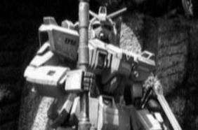

#### 3. Move the charging unit

Mobile suits may move up to 6" in the assault phase to close to their opponent. Suits equipped with Jump Packs may move up to 9".

#### 4. Fight Close Combat

To determine the order the suits attack, compare Initiative values of the pilots, adding in any bonuses listed under the Mobile Suit's profile. The process for determining the number of attacks is the same. The pilot may make one

To Hit Chart Opponent's Weapon Skill

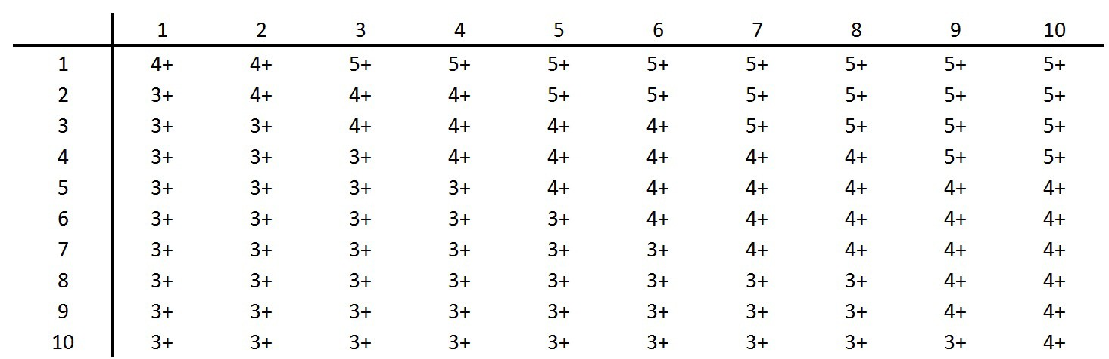

Attacker's Weapon Skill

#### Close Combat Weapons

Mobile Suits are usually armed with close combat weapons be it Beam sabre or Heat Hawk. These weapons add their own bonuses onto the strength of the Suit. So when you hit work out penetration as normal. A Mobile suit armed with two close combat weapons gains an extra attack, but cannot use its shield save.

#### Additional Close Combat Weapons

Although some suits are armed with two close combat weapons, like for example 2 Beam Sabres. Mobile suits lack the basic automated coordination needed to use both

weapons at the same time. A Mobile Suit can only use one Beam Sabre at a time.

#### Vehicles in Assaults

Because of their small size and lack of dedicated close quarters combat equipment, vehicles tend to shy away from melee with mobile suits. As a result, they may not initiate assaults or fight back. They may still be the subject of assaults however. These are resolved as normal. Because of their height advantages, mobile suits always strike at the top of the vehicle, as represented by the rear armor value.

#### Immobilized

Suits that are immobilized can still fight as normal. Their attack characteristic is reduced by –1 for each Immobilized result received.

#### Hand-to-Hand Multiple Combats

There are occasions were a Mobile Suit is up against more than one opponent. Pilots may choose to split their attacks against there opponents or concentrate on one assailant.

#### Leaving Combat

Mobile Suits may leave Combat during the movement phase, if he makes a successful Piloting Skill roll. The opponent suit recieves a free attack that automatically hits (roll for penetration as normal).

#### Fall Back & Crossfire

If a Mobile Suit Pilot fails his leadership role he will retreat. Note you cannot crossfire a Mobile Suit and if pursued, and caught the pursuing Pilot get a free back against the rear armor. If the pursued suit survives this free attack he has to turn and face his attacker again.

#### Cover in Assaults

A mobile suit in cover when assaulted strikes at initiative equal to its Pilot Skill, regardless of its Initiative score. This advantages represents a pilot's ability to effectively use terrain, based on his overall experience as a pilot.

Cover only functions in a logical direction. A Suit hiding behind a concrete wall does not gain a cover bonus if assaulted from behind.

#### Charge Bonus

When charging into combat, the assaulting suit gains +1 to its attack profile just for the turn it assaults.

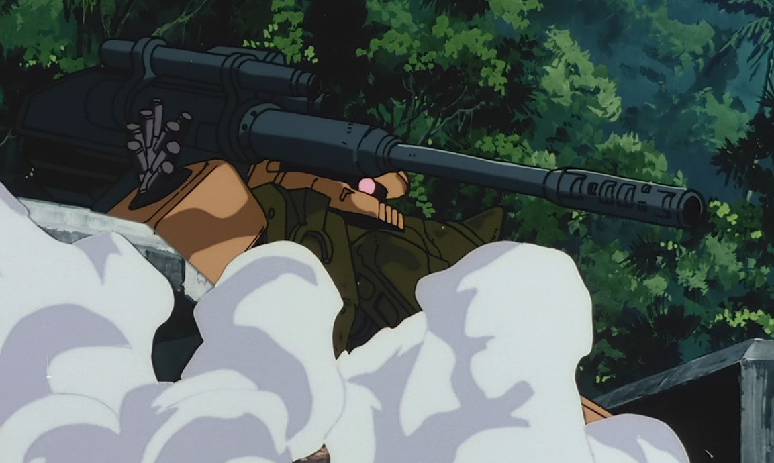

# Damage

#### Armor Value

Armor Values are different on each type of Suit and vehicle. They represent the strength and thickness of the alloy used to armor up the Suit. Armor values on Mobile Suits also differ depending on whether the shot hits the front, side or rear.

For Example. *The GM’s 100mm hits the Zaku twice on the front armor arc, the Zaku pilot makes his shield save for one of the shots, but the other makes it through. The GM pilot roles for penetration. The armor value of a Zaku’s front armor is 12. Rolling a D6, the pilot scores a 4, and adds this to the 100mm strength of 6 for an armor penetration total of 10. This is less than the armor value of the Zaku and so the shot bounces off.*

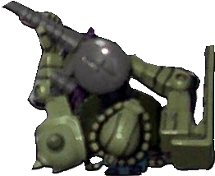

**FRONT**

**SIDE SIDE**

**BACK**

#### Armor Penetration

Once a hit is scored against a Mobile Suit roll a D6 and add the weapons Strength characteristic to it. Then compare it against the total of the Mobile Suits Armor value. Ordinance weapons fire such a huge projectile that they can smash apart armor with ease or turn the pilot to mush with the concussive force. When you roll for an Ordinance penetration roll two dice and pick the highest result.

If the total is less than the Suits armor value the shot bounces off it's armor and causes no damage.

If the total is equal to the Suits armor value the shot causes a glancing hit.

If the total is greater than the Suits armor value the shot causes a penetrating hit.

**BLIND SPOT**

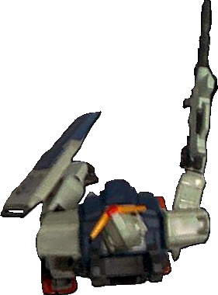

**SHIELD ARC**

For Example: *A Zaku II has been targeted by a Type E GM armed with Beam pistol. The GM scores a hit which the Zaku Pilot attempts to first save on his shield, but fails. The GM pilot rolls for penetration and the armor is breached. In desperation the Zaku pilot spends his one Wound point on his profile to save himself. He rolls a dice and scores a 4 saving his suit from damage.*

#### Cover Saves

Various elements of battlefield terrain can block incoming fire. To represent this, suits and vehicles standing within cover may take a cover save. On a successful dice roll, the terrain absorbes the hit, negating all damage. Cover saves are taken after a roll to hit but before armor penetration is rolled, as necessary. The required roll is dependent on the level of cover surrounding the target unit.

Light Terrain 6+

(Trees etc)

Medium Terrain (Unarmored Buildings etc)

5+

Heavy Terrain

(Armored Structures etc) 4+

**Wound Points**

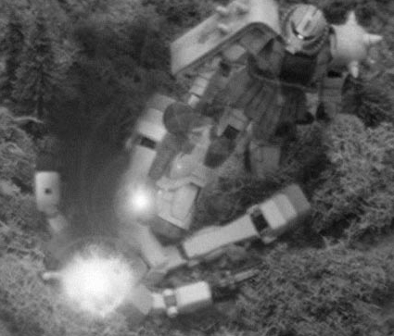

When you suit is hit and receives a penertrating hit, you may attempt to make a Wound point save. Every Wound point you spend you can make special 4+ save. Even if you fail you can spend another point in the same turn to try again and keep going until you have no wound points left. The Wound point save is only available to HQ and Elite pilots only.

Shield Saves

Almost all Mobile Suits have a layered armored shield of some description mounted on a arm or shoulder. This shield gives the Suit a degree of protection against enemy fire. A pilot can choose to take any hit – with the exception of Ordinance – on his shield if the shot is in his frontal fire arc. The shield save is 4+ on a D6, if he fails the role for armor penetration as normal. Remember shields can be used in close combat as well to ward off enemy blows

Warning! *Armored shields are very tough, put can only take so much punishment before they give. On a roll of a one regardless of shield type it cracks or shatters and is effectively useless for the rest of the game.*

*Note on Immobilized results – An immobilized suit cannot turn in place and if it received a second immobilized result its weapon are jammed pointing in the direction they last fired. Weapons jammed in place can only fire at units directly in their line of fire. A third result and the suit cannot fire any weapons and counts as destroyed (result four on the chart) for the rest of the game.*

|  |  |
| --- | --- |
|  | **Mobile Suit Ordinance Penetrating Hit Table - Roll a D6**  1 **Stunned** - May not move or shoot next turn  2 **Immobilized** – May not move. Suit can still shoot if the Pilot makes a successful PS roll each turn.  3 **Limb destroyed** - Roll a D6 1-3 **Leg** - suit is immobilized 4-6 **Arm** - Roll a D6  1-3 **Left Arm** - Shield can no longer be used 4-6 **Right Arm** - Weapon is destroyed   1. **Head Destroyed** – Suit is can only see using Gun camera, all movement halved and WS, BS & I are at -2. 2. **Destroyed** – Suit is collapses in a junked pile. 3. **Explodes** – Suits reactor is hit and goes nova. The resulting explosion causes a 3D6 radius blast measured from the center of the Suit. Any Mobile Suit or Vehicle caught in the explosion suffer a glancing hit on a 2+ and a penetrating hit on a 5+. |
| **Zaku in Quartered Cover** | **Zaku in Half Cover** |

Pilot Concussion

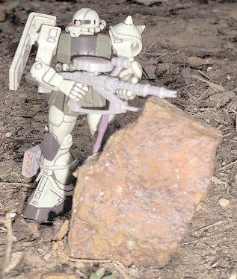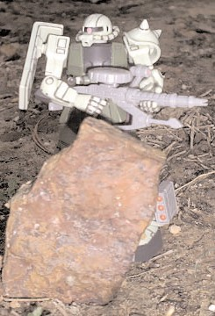

Mobile Suits can absorb a great amount of damage before collapsing. However the pilots inside cannot and they suffer the effects of the concussive force of the weapons used against them. Any hit that scores an armor penetration total of 11 or more regardless of penetration the pilot must take a PS roll or count as stunned next turn. Concussion is ignored if the pilot is in close combat as the desperation to stay alive overrides any pain caused.

**Vehicle Glancing Hit Table - Roll a D6**

1 -2 **Shaken** - May not shoot next turn

3 **Stunned** - May not move or shoot next turn. Pilot can still make saves on his shield.

4 **Weapon destroyed** – A Weapon chosen by the opponent is destroyed and can no longer be used

5 **Immobilized and Crew Stunned** - May not move or shoot next turn. The Vehicle is considered immobilized.

**6 Vehicle Destroyed** – The vehicle becomes a wreck.

Damage Rolls

If the Mobile Suits armor is breached make a Damage roll to see what happens. Roll a D6 and look up the result on the appropriate Damage Table. Please note there are separate Damage tables for glancing and penetrating hits.

*Note on Stun and shaken results – Do not add them together you can only get stunned and shaken once per turn. These results are not accumulative.*

**Vehicle Penetrating Hit Table - Roll a D6**

1 **Stunned** - May not move or shoot next turn

2 **Armarment Destroyed & Crew Stunned** – May not move or shoot next turn. The vehicle loses one weapon Strength 4 or higher. If it does not have a S4 weapon, it counts as immobilized

3 **Immobilized and Crew Stunned** - May not move or shoot next turn. The Vehicle is considered immobilized.

4-6 **Vehicle Destroyed** – The vehicle becomes a wreck.

6 **Vehicle Explodes** – All models within 6" take 1 S4 hit on a roll of 4+

|  |
| --- |
| **Mobile Suit Glancing Hit Table - Roll a D6**  1 -2 **Shaken** - May not shoot next turn   1. **Stunned** - May not move or shoot next turn. Pilot can still make saves on his shield. 2. **Limb destroyed** - Roll a D6 1-3 **Leg** - suit is immobilized 4-6 **Arm** - Roll a D6   1-3 **Left Arm** - Shield can no longer be used 4-6 **Right Arm** - Weapon is destroyed   1. **Weapon destroyed** – A Weapon chosen by the opponent is destroyed and can no longer be used 2. **Auto-Balance Destroyed -** All movement is halved Pilot must a successful PS roll when he moves. If he fails, the Mobile Suit collapses to the ground and is Immobilized. |
|  |
| **Mobile Suit Penetrating Hit Table - Roll a D6**  1 **Shaken** - May not shoot next turn  2 **Stunned** - May not move or shoot next turn  3 **Immobilized** – May not move. Suit can still shoot if the Pilot makes a successful PS roll each turn  4 **Limb destroyed** - Roll a D6 1-3 **Leg** - suit is immobilized 4-6 **Arm** - Roll a D6  1-3 **Left Arm** - Shield can no longer be used 4-6 **Right Arm** - Weapon is destroyed   1. **Head Destroyed** – Suit is can only see using Gun camera, all movement halved and WS, BS & I are at -2. 2. **Destroyed** – Suit is collapses in a junked pile. |

**Vehicle Ordinance Penetrating Hit Table - Roll a D6**

1 **Stunned** - May not move or shoot next turn. Pilot can still make saves on his shield.

1. **Weapon destroyed and Crew Stunned-** A Weapon chosen by the opponent is destroyed and can no longer be used and the vehicle may not move or shoot next turn
2. **Immobilized and Crew Stunned -** The vehicle may no longer move and may not fire next turn
3. **Vehicle Destroyed** – The vehicle is reduced to a wreck which remains on the board as difficult terrain

5-6 **Vehicle Explodes -** All models within 6" take 1 S4 hit on a roll of 4+

Weapons

Mobile Suits carry a variety of differet weapons classes to suit various battlefield roles. These can range for large caliber machine guns to bazookas to highly advanced E-cap powered beam weaponry.

#### Pistols

Pistols are small, one handed designed to be used at close range.

Pistols may be fired once if a Mobile Suit moves or twice (roll two dice) if it remains stationary during the movement and assault phases

#### Rapid Fire

Rapid Fire weapons are typically large rifle style weapons which are fed by a magazine and capable of firing in a semi-automatic or fully-automatic rate of fire. These weapons are particularly effective at close range.

Pistol – Weapon can fire twice (roll two dice) if suit stays still for turn

Rapid Fire – Weapon can fire twice up to half range or once up to maximum range if suit stays still. Or once up to half range if suit moves.

Assault – Weapon can fire the number of dice indicated by the number next to type regardless of movement.

Heavy – Suit must remain still to fire this weapon, can fire as many times as number next to type indicates.

Ordinance – Suit must remain still and not fire any other weapons to use an Ordinance weapon. Uses the big Ordinance template, range must be guessed and use scatter dice to work out hits.

Blast – Suit can move and fire as many times as indicated by type. Uses smaller blast template.

|  |  |  |  |  |  |
| --- | --- | --- | --- | --- | --- |
| Weapons | Range | Short | Long | Str | Type |
| 90mm Machine Gun | 18” | +1 | - | 5 | Assault 1 |

#### Ordinance Weapons

Unlike normal weapons, large Ordinance weapons often deal damage to their target even if they do not directly strike it. To represent this, ordinance shooting follows a different system, making use of the large Warhammer 40,000 Blast Template.

**1.** Place the blast template over the target unit

1. Roll the Warhamer 40,000 Scatter die . If the crosshair is rolled, the shot is on target. Otherwise, move the center of the template 2D6" in the direction the scatter die points.
2. Any unit fully under the template is hit. Any partially but not fully under the template is hit on a roll of 4 or more.
3. Calculate armor penetration and damage as normal

#### Vehicle Weaponry

Unlike Mobile Suits, vehicle-based weapons are divided into 3 categories: Ordinance, Main and Defensive. Ordinance weapons are any weapon which uses an ordinance

blast template. Main Weapons are any weapon of strength 7 or higher. Defensive Weapons are those with a strength of 6 or lower

Vehicles which remain stationary during the movement phase may 1 Ordinance weapons or all Main and Defensive Weapons. If the vehicle move 6" or less, it may fire 1 Main and all Defensive Weapons or 1 Ordinance Weapon. If it moves move than 6", the crew must focus entirely on movement and it may not fire any weapons.

All Main and Defensive weapons or 1 Ordinance

No Weapons

Stationary

7"-12"

Vehicle Movement

Up to 6"

1 Main and all Defensive weapons or 1 Ordinance Weapons



MOBILE SUIT ARMY LISTS

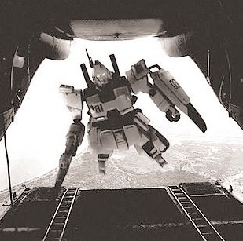

## A Brief Introduction - Using the Team List

The Mobile Suit List is structured a little different to regular Warhammer 40,000 lists. It is split into two sections (a lot like the Armored Company list in Chapter Approved): the army list and the Mobile Suit Hanger. You use the Army list to pick the Pilots you want to make up your Team and then use the Mobile Suit Hanger to decide what type of suit your Pilot would be jockeying.

The reason for this system is simple – many of the Pilots on the list can pick from a number of different types of Mobile Suit. This cuts down repetition in the list and makes it a lot easier to understand.

The army list are used in conjunction with the Standard Mission force organization chart in the Warhammer 40,000 rulebook. The chart is split into five categories (HQ, Elites, Troops, Fast Attack and Heavy Support), which correspond to sections in the army list. To choose your pilot you need to look in the relevant section of the list. The entry will also tell you what types of mobile suit can be chosen for that pilot from the Mobile Suit Hanger. Refer to the Hanger to find the points cost of the Mobile Suit and the weapon options and upgrades you can get for it. Remember you cannot field Suits that are equipped with the weapons or upgrades not shown on the Mobile Suit model.

The total points cost for the unit is equal to the points noted for the Suit and its upgrades in the hanger, plus the points for the pilot in the army list. Subtract this total from your army’s total points, and then go back and make another choice. Continue to do this until you have spent all your points. Then get ready to rumble…

Important Note The Mobile suits add additional bonuses to the Pilots profile make sure you note these on the Pilots profile, don’t forget to replace the pilots strength with the Mobile Suits strength while he is piloting the machine. Also note that Mobile suits can only be armed with one hand held mobile suit weapon system.

## MS Team List Federation

The Federation Mobile Suit force is large a diverse organization with many specialized formations such as the Pathfinders and Sniper units. The most common military unit to be found is the Mobile Suit Teams, three or more Mobile Suits led by a Commander who under take patrol duties, engage and destroy missions, and even infiltration operations.

The Mobile suit team is the jack of all trades and is a vital part of the Federation armed group. The list below is designed to reflect the nature of a Mobile Suit team and any support units that might be assigned to them to complete their mission – such as Guntanks or even Guncannons.

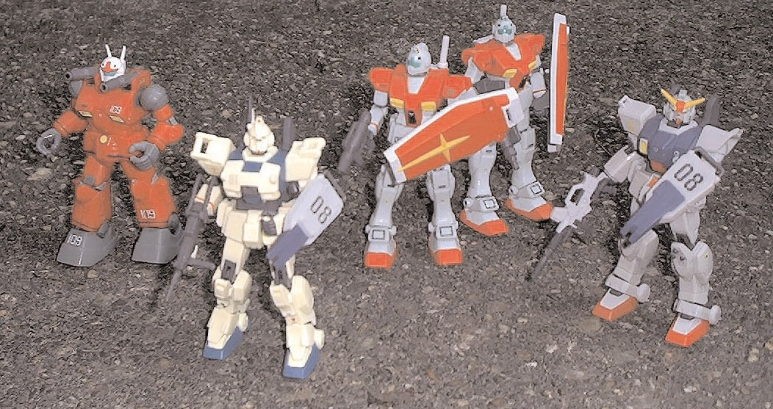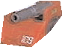

**Troop - Pilots Kennedy**

**& Curren in RGM-79E’s**

**- 320pts**

**Elite - Veteran Pilot Ide in RX-79 - 255pts**

**Federation Mobile Suit Team Eight, part of the Lougheed Battalion stationed in North America.**

**Currently in action against the Zeon forces in that**

**area.**

**Heavy Support - Pilot Buyaki in RX-77**

**- 260pts**

**This is a good example of a 1100 point Mobile suit**

**team**

**HQ - Lieutenant Tarrant in EZ8 - 265pts**

## The Mobile Suit Federation Pilot list Headquarters - Team Leader

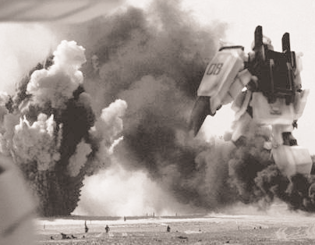

|  |  |  |  |  |  |  |  |  |  |
| --- | --- | --- | --- | --- | --- | --- | --- | --- | --- |
|  | **WS** | **BS** | **S** | **W** | **I** | **A** | **PS** | **LD** | **PV** |
| Ensign | 3 | 4 | 3 | 1 | 3 | 2 | 8 | 8 | 25 |
| Lieutenant | 4 | 4 | 3 | 2 | 4 | 3 | 8 | 8 | 35 |
| Captain | 4 | 4 | 3 | 3 | 5 | 4 | 8 | 9 | 50 |

**Unit Size:** *One Suit*

**Mobile Suit Options:** *RGM(E)-79 GM, RGM-79(G) GM, RX-79(G) Gundam, RX-79 (G) Ez8 Gundam Extra Zero-Eight, or RX-78-2 Gundam*

**Independent Character:** *The Team Leader is an Independent Character and follows the independent character special rules in the Warhammer 40,000 rulebook.*

## Elite

**Veteran Pilots**

#### WS BS S W I A PS LD PV

Veteran Pilot 4 4 3 1 3 2 8 7 25

## Troops Pilots

#### WS BS S W I A PS LD PV

**Unit Size:** *One Suit*

**Mobile Suit Options:** *RGM(E)-79 GM, RGM-79(G) GM, RX-79(G) Gundam or RX-78-2 Gundam.*

**Independent Character:** *A Veteran Pilot is an Independent Character and follows the independent character special rules in the Warhammer 40,000 rulebook.*

## Sniper

|  |  |  |  |  |  |  |  |  |  |
| --- | --- | --- | --- | --- | --- | --- | --- | --- | --- |
|  | **WS** | **BS** | **S** | **W** | **I** | **A** | **PS** | **LD** | **PV** |
| Veteran Pilot | 2 | 5 | 3 | 1 | 3 | 1 | 8 | 7 | 30 |

**Unit Size:** *One Suit*

Pilot 3 3 3 - 3 2 7 7 15

**Unit Size:** *One Suit*

**Mobile Suit Options:** *RGM(E)-79 GM, RGM-79(G) GM RX-79(G) Gundam or Type 61 Battle Tank.*

**Mutial Support:** *Pilots are trained to work in concert with each other and are often too inexperienced to operate alone. Therefore Pilots must always attempt to remain within 8” of another MS unit.*

## Heavy Support Artillery Pilot

**Mobile Suit Options:** *RGM-79(G) Sniper GM.*

**Independent Character:** *A Sniper Pilot is an Independent Character and follows the independent character special rules in the Warhammer 40,000 rulebook.*

**Infiltrate:** *A Sniper Pilot is an expert in positioning his suit for the best shot before the battle. If the scenarios allows it a Sniper Pilot may infiltrate using the rules stated in that scenario*

#### WS BS S W I A PS LD PV

Artillery Pilot 3 4 3 - 3 2 7 7 20

**Unit Size:** *One Suit*

**Mobile Suit Options:** *RX-75 GunTank, RX-77-2 Guncannon, or RX-79(G) Gundam.*

**Special Note:** *It takes a crew of two to pilot the GunTank. If you choose this option from the list you must buy an extra Heavy Support Pilot - he therefore counts as a single choice on the list.*

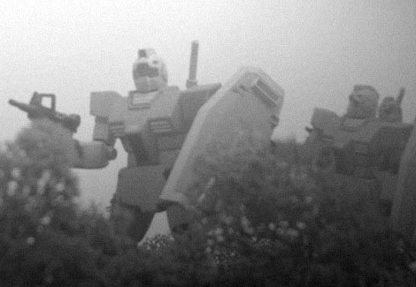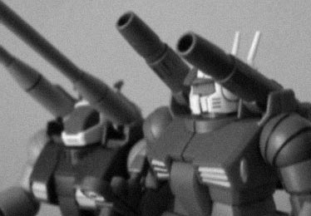

## Federation Mobile Suit Hanger

**RGM-79(G) Type G**

#### WS BS S W I A PS LD

**RGM-79 (E)**

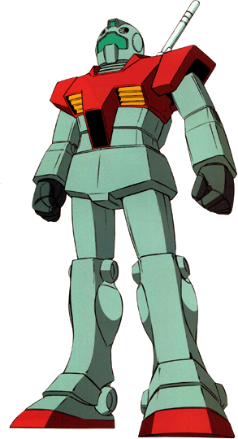

Pilot Bonus

- +1 5 - - - - -

## RGM-79(E) Type E

**Type E GM**

The first mass-produced Federation Mobile Suit and standard space Mobile Suit in the Federation forces. On the ground it was slowly being phased out by the Type G, until the Zeon invaded earth, and it was pressed into service again forming the backbone of the Fed’S-MS forces. The suit is normally assigned to line units and defensive actions- it’s a very capable design able to carry and power most Federation Mobile Suit weapon systems.

#### Armor Values Front Side Rear PV

RGM-79 (G) 12 10 10 100

#### RGM-79 (G) Standard equipment & weapon:

The RGM-79 (G) comes with this equipment and weapons as standard: Targeter, 2 beam sabres & jump pack

#### RGM-79 (G) Optional equipment & weapon options

The RGM-79 (G) can be equipped with the following optional equipment and weapons: Shield (+25pts), beam pistol

(+20pts), 100mm machine gun (+30pts) or bazooka (+45pts) or missile launcher (+50pts)

## RX-79 (G) Type G

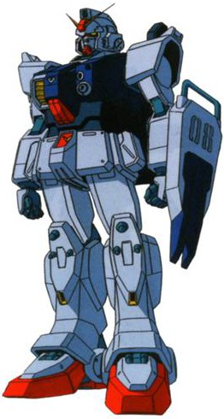

**Ground Type Gundam** The RX-79 Gundam is still a prototype with a very limited production run when the Zeon’s invaded earth. It was quickly pressed into service with the elite

#### WS BS S W I A PS LD

of the Federation Mobile Suit

Pilot Bonus

- - 5 - - - - -

forces getting to jockey it. The

#### Armor Values Front Side Rear PV

RGM-79 (E) 11 10 10 90

#### RGM-79 (E) Standard equipment & weapon:

The RGM-79 (E) comes with this equipment and weapons as standard: Twin-linked 60mm Vulcans, beam sabre & jump pack

#### RGM-79 (E) Optional equipment & weapon options

The RGM-79 (E) can be equipped with the following optional equipment and weapons: Shield (+25pts, Targeter (+5pts), beam pistol (+20pts), 100mm machine gun (+30pts) or bazooka (+45pts)

Note, an RGM-79 (E) cannot use its shield and a heavy weapon at the sametime.

Gundam suits soon proved to be more of match for the then superior Zaku.

As the RX-79 Gundam is an experimental suit – so spare parts for suits were always extremely hard to acquire. Over the course of the one year war the Gundams started to resemble the RGM-79 G’s as the Field Techs interchanged parts

between the two suits to keep the Gundam’s in the field.

## RX-79(G) Gundam

#### WS BS S W I A PS LD

**RGM-79 (G)**

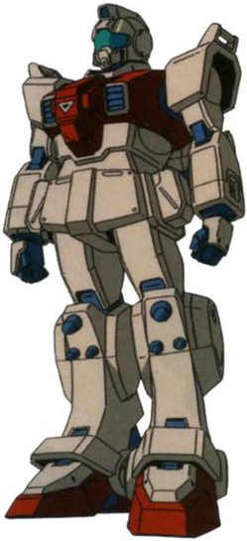

Pilot Bonus

- +1 6 - +1 +1 - -

## Type G Ground Type GM

The Type G is quickly becoming the standard issue Grunt suit of the Federation Mobile Forces. Its rugged, well powered and adaptable, its armor is heavier and it’s capable of mounting a wide variety of Federation MS weapon systems.

Many of its parts and systems are interchangeable with the RX-79(G) making field repairs for both units very easy. Many times Federation field Techs have rebuilt a suit using the shattered remains of an

RX-79(G) and RGM- 79(G).

#### Armor Values Front Side Rear PV

RX-79 (G) 13 12 10 160

#### RX-79 (G) Gundam Standard equipment & weapon:

The RGM-79 (G) Gundam comes with this equipment and weapons as standard: Targeter, 2 beam sabres, 60mm vulcans, one-shot multi- launcher (counts as cracker grenade) & jump pack

**RX-79 (G) Gundam Optional equipment & weapon options** The RX-79 (G) Gundam can be equipped with the following optional equipment and weapons: Shield (+25pts, beam rifle (+40pts) 100mm machine gun (+35pts), bazooka (+45pts), or 180mm cannon (+50pts)

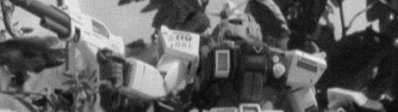

## RX-79 (G) Ez8 Ground Type Gundam

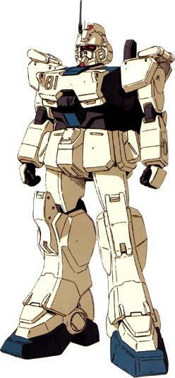

**RX-77-2 Guncannon**

#### WS BS S W I A PS LD

The Ez-8 Gundam is the perfect

Pilot Bonu~s

- +1 5 - - - - -

example of Field Tech’s adaptability to the RX-79 part situation. The Ez-8 is a field modification and is normally built around the core of a badly damaged RX-79 and incorporates many parts from other salvaged RGM-79(G). Ez-8’s are fitted with additional armor baffles and improved communication equipment.

To date there are only seven Ez- 8’s in active service. The most famous being Extra Zero Eight piloted by Lieutenant Shiro Armada, the suits performance was excellent able to go toe to toe

and beat a Gouf Custom, the primary Zeon close-combat suit.

## Ez8 (G) Gundam

#### Armor Values Front Side Rear PV

GunCannon 12 11 10 150

#### Rx-77-2 Guncannon Standard equipment & weapon:

The Guncannon comes with this equipment and weapons as standard: Targeter & twin-linked 60mm Vulcan cannons

The RX-77-2 GunCannon must mount either a pair of 240mm cannons (+65pts) or twin-linked spray missile launchers (+50pts)

**RX-77-2 Guncannon optional equipment & weapon options:** The Guncannon can be equipped with the following optional equipment. Jump Pack (25pts), Beam Rifle (+40pts) or 100mm Machine-gun (+35pts

## RX-75 Production Guntank

|  |  |  |  |  |  |
| --- | --- | --- | --- | --- | --- |
|  | **WS BS S** | **W I** | **A** | **PS LD** |  |
| Pilot Bonus | - +1 6 | - +1 | +1 | - - |
| **Armor Values** | **Front** | **Side** |  | **Rear** | **PV** |
| Ez8 (G) | 13 | 12 |  | 10 | 160 |

#### Ez8 (G) Gundam Standard equipment & weapon:

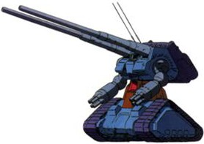

The Ez8 (G) Gundam comes with this equipment and weapons as standard: Targeter, beam sabre, improved comms, ablative armor & jump pack

#### Ez8 (G) Gundam Optional equipment & weapon options

The Ez8 (G) Gundam can be equipped with the following optional equipment and weapons: Shield (+25pts), beam rifle (+40pts)

or 100mm machine gun (+35pts)

**RX-77-2 Guncannon** Another prototype Mobile Suit that found itself

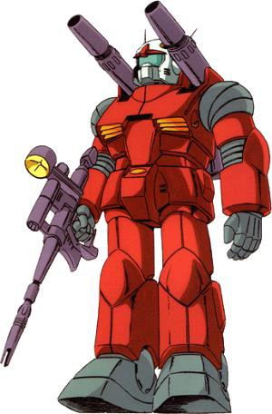

pressed into action during the Zeon invasion was the Guncannon. The suit was an experiment in mobile mid- ranged fire support and mounts a pair of 240mm cannons on its shoulders.

A limited number of the suits were built and the Guncannon suffered throughout the One Year War, due to a lack of parts.

Several Guncannons where re- equipped in the field with missile launchers due to the scarce ammunition for their cannons. Some even used hand held weapon Mobile Suit weapons systems to supplement their firepower.

A prototype Mobile Suit that was in the early stages of mass- production when the invasion hit. The Gutank is a mobile artillery piece that mounts cut down versions of mass-reaction cannons. It has extreme of mobility as its primary mounted on tracked system. The suit also it takes two pilots to operate it. One to pilot and the other to fire the suits weapon systems. It’s primary role is long- ranged fire-support and its cannon is capable of blowing holes through starships!

## RX-75 ProductionGutank

#### WS BS S W I A PS LD

Pilot Bonus - +1 5 - - - +1 -

#### Armor Values Front Side Rear PV

GunTank 11 11 10 240

#### RX-75 Production Gutank standard equipment:

The RX-75 GunTank comes with this equipment and weapons as standard; Targeter, 120mm low-reaction cannons and twin missile launcher

*Note; The Production Gutank requires a team of two pilots to operate. If you are using this suit in your team you must purchase two pilots to use it!*

## Type 61 Battle Tank

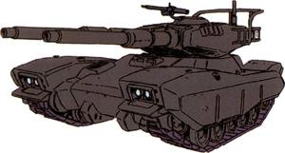

The Type 61

is the Federations main battle tank and

was used extensively during the defense of earth.

The Type 61 crews had the unenviable task of going up against the vastly superior Zeon Mobile Suits. Despite horrendous casualties and through some very hard-learned lessons, the Tankers were able to slow down and eventually stop the Zeon advance.

Even with the advent of the Federation Mobile Suits the Type 61 still sees combat action. It's not uncommon for several Tank squadrons to be assigned to support of a Mobile Suit battalion, and to accompany them into battle. In dense terrain like cities or jungle, these Tanks can give Zeon pilots a considerable headache.

Indeed many Tank squadrons have earned themselves nicknames for their Mobile Suit hunting abilities. Like the famous 31st 'Leg Breakers' Squadron, led by Commander Steve Voight - a bear of a man who is determined to prove the worth of his Tanks. His tacticshave met with great success and his squadron has accredited 10 kills and over two dozen immobilization's to their name.

## Type 61 Federation Battle Tank

#### WS BS S W I A PS LD PS

Crew Profile 3 3 3 1 3 1 6 7 -

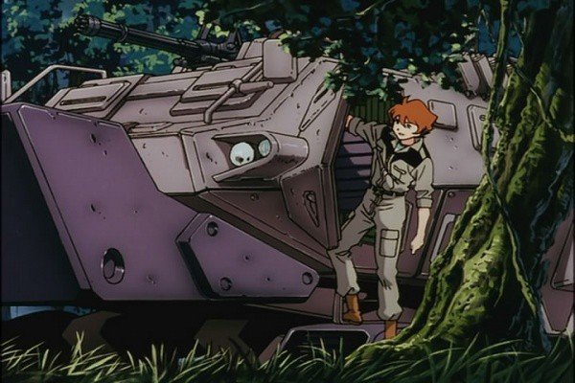

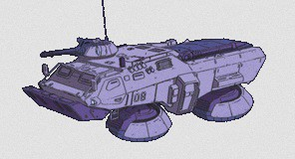

## Type 74 Hover Truck

#### Armor Values

**Front Side Rear PV**

With the advent of the Minosky particle ground radar is

Type 61 Tank 9 8 8 50

#### Type 61 Battle Tank Standard equipment & weapon:

The Type 61 Tank comes with this equipment and weapons as standard: 150mm Cannon (same as the 100mm Machine Gun)

#### Type 61 Army Entry

*The Type 61 counts as a Troop choice. You can have upto four Type 61’s per troop slot on the Force Organization chart. You do not need to purchase any pilots to take this Tank as if comes already crewed. Plus no Mobile Suit pilot in there right mind would step inside these metal coffins.*

#### Type 61 Battle Tank Special Rules

The Type 61 Battle Tank is a vehicle and follows all the rules featured for vehicles in Warhammer 40,000 rulebook.

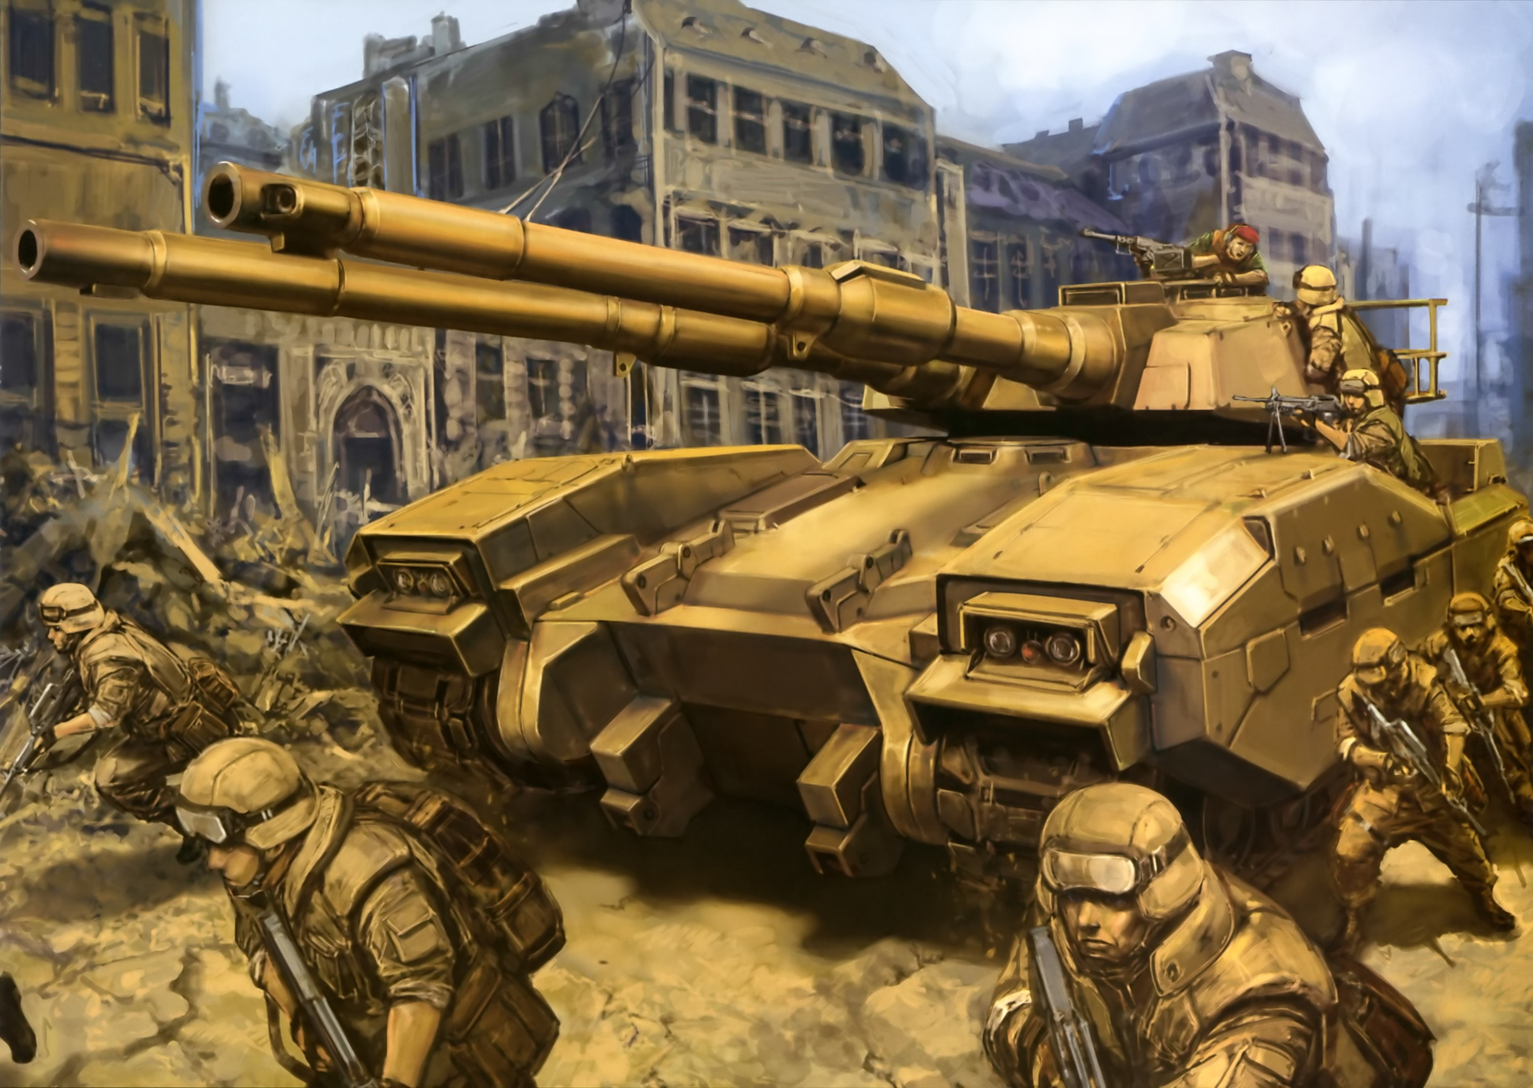

virtually impossible. The old ‘fashioned’ method of spotting

and scouting for the enemy has been re-introduced. With radar now as good as useless the Hover truck also has another system to track enemy suits called ground sonar. A skilled operator can track any suit by tremors alone within a mile radius, then relay the information to his team for fire support or attack vectors. The Federation Hover truck was introduced to support Mobile suits in a combat zone. It carries tools needed for field repairs and all the supplies the team needs for its combat mission.

## Hover Truck

#### WS BS S I A W LD PS

Crew Profile 3 3 3 3 1 1 7 -

#### Armor Values Front Side Rear PV

Hover Truck 6 5 5 50

**Hover Truck Standard equipment & weapon:** 20mm Machine gun (no stats anti-infantry only) and ground sonar.

#### Type 74 Army Entry

*The Type 61 counts as single Troop choice.*

#### Type 74 Hover Truck Special Rules

The Hover truck while useless in a duel between Mobile suits is still an essential part of a MS team.

**Ground Sonar** - This special radar allows a skilled operator to track suits by ground tremors alone. The Truck cannot move while using its sonar and it can detect infiltrating targets and ambushers within 36”. Plus relay firing patterns to any Mobile suit within 18” allowing a +1 to hit or a re- roll of the scatter dice.

## RGM-79G Sniper GM

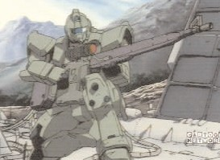

#### WS BS S W I A PS LD

Pilot Bonus

- +1 5 - - - - -

#### Armor Values Front Side Rear PV

RGM-79G 11 11 10 100

#### RGM-79 Sniper Standard equipment & weapon:

The RGM-79 Sniper comes with this equipment and weapons as standard: Sensor Targeter, Improved comms & beam sabre **RGM-79 Sniper Optional equipment & weapon options**

The RGM-79 Sniper can be equipped with the following optional equipment and weapons: Jump-Pack (+20pts) Long beam rifle (+100pts - see special rules below), External Power Supply (+50pts

- see special rules below) or a 100mm machine gun (+40pts)

## RGM-79G Sniper GM

The RGM-79[G] GM Sniper was the first of a long line of GM variants, although in a sense it wasn't much of variant. The Snipers various hand-carried standard weapons were replaced with a large, long-range beam rifle, and the unit also had its targeting software upgraded to handle the precise targeting needed to use snipe with such a weapon. The energy required to fire such a powerful rifle, was more than the GM's power generator could produce.For sustained use the rifle had to be connected via cable to an external power supply and cooling system on a support vehicle.

#### RGM-79 Sniper Special Rules

**Sensor Targeter:** The RGM-79 Sniper is equipped with a Sensor Targeter, this allows the Sniper Suit to detect infiltrating targets and ambushers within 18” if it stay stills for one turn and does not fire.In every other way it acts like a normal Targeter and its bonus has already been added to the suits profile

**External Power Supply:** The RGM-79 Sniper can make use of an external power supply which allows it to fire more than 3 times. It is supplied from a Hover Truck as listed above. It must remain within 2" to use the external power supply

#### LONG BEAM RIFLE

This cut-down version of a starship cannon has only recently been developed for use with Mobile Suits. These specialized support units known as Snipers are usually piloted by the best shot in the Mobile Suit battalion. The Beam Rifle is an extremely heavy piece of equipment even for Mobile suit to carry, it's also large and bulky, and although it can operate on the Mobile Suits power systems for continuous use it needs an external power source and cooling system.

The rules presented here are for independent firing as it is assumed that the Sniper unit has been attacked to the team for specific task and to keep pace with the MS team cannot bring along its external support teams.

Special Rules

*The Long Beam Rifle is so heavy and requires a reasonable amount of time to build up power for firing, the Mobile Suit carrying it cannot move and fire during the same turn. Also the suit cannot use any other weapons mounted on it as all power is channeled to the weapon, cooling and targeting systems. In addition the Mobile Suit carrying the Long Beam Rifle cannot carry or use a shield at the same time.*

*As the Long Beam Rifle is being operated independently from its external power supply, the gun has a limited amount of shots before it needs to be recharged by its support crew. Therefore the Long Beam Rifle cannot be fired anymore than three times before it needs recharging. Recharging cannot be done on the battlefield, as it requires the suit to be immobile for 24 hours as it shunts power to the rifles capacitors - or it has to be recharged by the support crew.*

*If the arm carrying the Long Beam Rifle is destroyed there is chance that the unused energy in the weapons capacitors well go off. Roll a D6 on a one or six the weapon explodes and the suit carrying it suffers an addition Strength 10 hit (roll for penetration as normal).*

*Any target suit cannot use his shield to block the Rifles beam; such is the weapons power that it would burrow a hole through the shield armor before hitting the Gundam on the other side.*

*When the Mobile Suit is firing the Long Beam Rifle apply the to hit modifier presented in the table below - do not apply the normal modifiers as the suits advanced targeting computers take many more factors into account than a normal suit. Because the Rifle takes a few moments to build up its power, an agile target like a Mobile Suit or Tank can move out ofits way or dodge the shot. The score to hit is therefore reduced depending on the move of the target. Roll to hit as normal and apply these modifiers.*

#### Targets Movement 0-2" 2-4" 4-6" 7'+

To hit Penalty -1 -2 -3 -4

Note... *the rule of one and six does not apply to firing the Long Beam Rifle. Also targets larger than a Gundam (yes there is some!) automatically gain a*

*+2 to hit on the dice.*

*The Long Beam Rifles fires a continuous stream of energy concentrated on a point on the target's armor. This means the armor penetration is not worked out in the standard way as the beam burrows into the target. This gives the target a chance to still shy away from the beam or the materials of the armor may dissipate the beams energy. The beam penetration strength is worked out on the thickness of a*r*mor. For example a target with an armor thickness of 9-11 the Sniper pilot would roll 3D6 adding them together scoring somewhere between 3 to 18*

#### Armor Thickness 1-4 5-8 9-11 12-14 15+

Penetration D6 2D6 3D6 4D6 5D6

## LONG BEAM RIFLE WEAPON PROFILE

#### Weapon Range Short Long Str Type

Long Beam Rifle 12”-120” - -1 Special Heavy

## RX-78-2 Gundam

The RX-78 Gundam, a product of the Earth Federal Forces' Operation V program, is a state-of-the-art close combat mobile suit, developed for use by the Federdation Navy. This versatile prototype is equipped with the same sturdy Luna Titanium armor and adaptive learning computer as the Guncannon and Guntank. Its armed with a pair of lethal beam sabers, and can carry a hyper bazooka or a powerful beam rifle for longer-range combat.

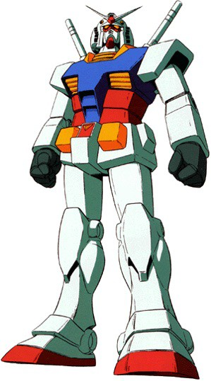

A total of eight RX-78 units were produced at Jaburo, the Federal Forces headquarters. In August of UC 0079, three of these were sent to the Side 7 research colony for further

On September 18, the mobile assault carrier White Base arrived at Side 7 to collect the prototypes and their vital test data. As fate would have it, a Zeon cruiser spotted the White Base in transit and launched a surprise attack on Side 7. With most of the White Base crew and the Side 7 garrison wiped out, it fell to a fifteen-year-old civilian named Amuro Ray to pilot the sole surviving Gundam prototype and fend off the attackers. In the months to come, Amuro would become the greatest ace of the One Year War, and the RX-78-2 Gundam would become a legend.

## RX-78-2 Gundam

#### WS BS S W I A PS LD

Pilot Bonus +1 +1 6 - +1 +1 +1 -

#### Armor Values Front Side Rear PV

RX-78 -2 13 13 10 200

#### RX-78-2 Gundam Standard equipment & weapon:

The RX-78-2 Gundam comes with this equipment and weapons as standard: Targetor, beam sabre, twin-linked 60mm vulcans

& jump pack

#### RX-78-2 Gundam Optional equipment & weapon options

The RX-78 Gundam can be equipped with the following optional equipment and weapons: Shield (+25pts, beam rifle (+45pts)

testing. These three units were upgraded to the RX-78-2 version, with higher power output to satisfy its beam rifle's energy requirements, and their initial color schemes were changed to eye- catching demonstration colors.

100mm machine gun (+40pts) or bazooka (+55pts)

#### RX-78-2 Army Entry

*The RX-78 Gundam can only be used by Federation HQ and Elite Pilots only.*

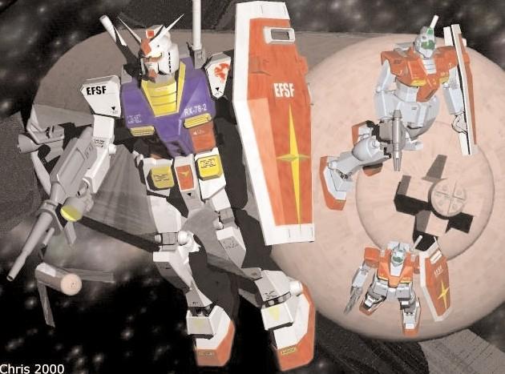

## Zeon Expeditionary Force List

During the Earth Invasion the Zeon forces had the upper hand with superior Mobile Suits, armor, weapons and pilots. Their Mobile Suit teams are used to working together and trained in close support, recon and raiding tactics. The MS Teams often worked closely with more conventional forces such as the Magella Attack Tank, and Doff Fighters operating as a cohesive unit. The Teams even use adapted Lugan Recon planes for a rapid redeployment and terror raids behind enemy lines.

The backbone of the Zeon forces is the Zaku suit, which is adaptable, easy to maintain and largely superior too most Federation suits. Even more specialized Mobile Suits can be found in the Zeon forces as well, like the close combat Gouf and the heavier technological impressive Dom.

## The Zeon Expeditionary Force Pilot list Headquarters - Team Leader

#### WS BS S W I A PS LD PV

|  |  |  |  |  |  |  |  |  |  |
| --- | --- | --- | --- | --- | --- | --- | --- | --- | --- |
| Lieutenant | 4 | 4 | 3 | 1 | 4 | 3 | 8 | 8 | 35 |
| Captain | 5 | 4 | 3 | 2 | 4 | 4 | 8 | 9 | 45 |
| Major | 5 | 4 | 3 | 3 | 4 | 5 | 8 | 9 | 55 |

**Unit Size:** *One Suit*

**Mobile Suit Options:** *MS-05S Zaku I, MS-06S Zaku II Command Type, MS-07B Gouf, MS-09 ‘Dom, MS-14A Gelgoog, MSM-03 Gogg or MSM-07 Z-Gok*

**Independent Character:** *The Team Leader is an Independent Character and follows the independent character special rules in the Warhammer 40,000 rulebook.*

## Elite

**Veteran Pilots**

#### WS BS S W I A PS LD PV

Veteran Pilot 4 4 3 1 3 2 8 7 30

**Unit Size:** *One Suit*

## Heavy Support Pilot

#### WS BS S W I A PS LD PV

Pilot 3 4 3 - 3 2 7 7 20

**Unit Size:** *One Suit*

**Mobile Suit Options:** *MS-05B Zaku I, MS-06F/J Zaku II, MS-09 Dom or Magella Attack Tank*

## Zeon Mobile Suit Hanger

**MS-05B Zaku I** Introduced in U.C. 0075, the MS-05B Zaku I was the

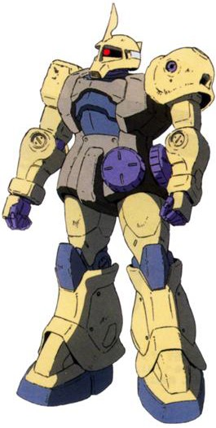

Principality of Zeon's first true mass-production model mobile suit. The Zaku I was soon replaced by the MS-06F Zaku II as the mainstay of Zeon's mobile suit forces. During the war's opening days, Zaku Is were used in other roles, including gassing of colony populations and attaching booster engines to space colonies to hurtle them towards Earth. After the crushing defeat of Operation Odessa, Zaku I's reinforced their faltering main forces and saw some of the bitterest action of the entire war, fighting desperate holding actions often against superior Federation Mobile suits, fighting alongside advanced mobile suits such as MS-14 Gelgoog units used during Zeon's last stand at the Space

**Mobile Suit Options:** *MS-05B Zaku I MS-06F/J Zaku*

## MS-05B Zaku I

Fortress A Baoa Qu.

*II, MS-07B Gouf, MS-07H-8 Gouf Flight Type, MS-09 Dom, MS-14A Gelgoog, MSM-03 Gogg or MSM-07 Z-Gok*

**Independent Character:** *A Veteran Pilot is an Independent Character and follows the independent character special rules in the Warhammer 40,000 rulebook.*

## Troops Pilots

#### WS BS S W I A PS LD PV

Pilot 3 3 3 - 3 2 7 7 15

**Unit Size:** *One Suit*

**Mobile Suit Options:** *MS-05B Zaku I, MS-06F/J Zaku II, MS-09 Dom, MSM-03 Gogg or MSM-04 Acguy.*

**Mutial Support:** *Pilots are trained to work in concert with each other and are often too inexperienced to operate alone. Therefore Pilots must always attempt to remain within 8” of another MS unit.*

#### WS BS S W I A PS LD

-

|  |  |  |  |  |
| --- | --- | --- | --- | --- |
| Pilot Bonus | - - | 5 | - - | - - |
| **Armor Values** | **Front** |  | **Side** |  |
| Zaku I | 12 |  | 10 |  |

#### Rear PV

10 80

#### MS-05B Zaku I Standard equipment & weapon:

The MS-05B Zaku I comes with this equipment and weapons as standard: Heat Hawk & jump pack.

**MS-05B Zaku I Optional equipment & weapon options:** The MS-05B Zaku I can be equipped with the following optional equipment and weapons: Targeter (+5pts), 90mm MMP- 70C Machine Gun (+45pts), Panzer Faust (Single Shot) (+10pts), 120mm machine gun (+40pts), 175mm Cannon (+45pts) or 280mm Bazooka (+45pts)

**MS-05B Zaku I Command Upgrade(+30pts):** The MS-05B Zaku I may be upgraded to an MS-05S Zaku I Command (+2. It replaces the Heat Hawk with and Heat Sword and gains +1 to Side Armor.

*Note this upgrade may only be selected by HQ Pilots*

## MS-06J Zaku II

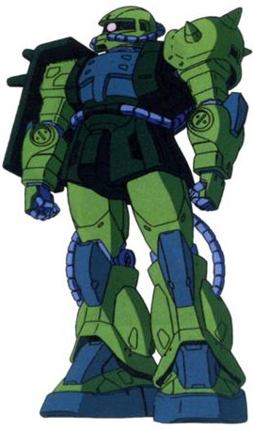

**MS-06F/J Zaku II**

The Zaku II is an advanced design sharing only the body design of the first ever mass- produced Mobile Suit the Zaku. It’s superior to most Federation Mobile Suit and can be modified to carry several different weapon systems. The Zaku II forms the backbone of the Zeon mobile forces. The Zaku II F Type was a lightened, improved version of the original C Type which served as the baseline for further improvements. The Zaku II J Type was a ground combat variant which made used a more powerful reactor but fewer verniers.

## MS-06S Zaku II Command Type

This rare variant of the Zaku II is a high-performance model designed for company commanders and ace pilots. The

communications antenna on its head identifies it as a command unit, and its thruster output is 30% higher than that of a normal Zaku II. This limited-edition mobile suit is assigned only to deserving Zeon aces like Major Char Aznable, who won renown by single- handedly destroying five Federation battleships during the Battle of Loum.

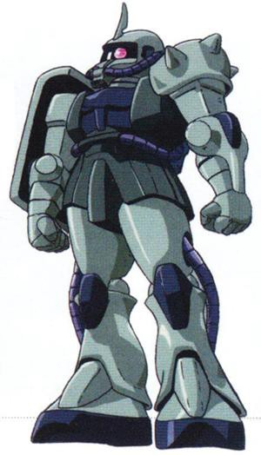

Pilot Bonus

#### Armor Values

**WS BS S W I A PS LD**

- - 5 - - +1 - -

#### Front Side Rear PV

Zaku II 12 12 10 110

#### MS-06J Zaku II Standard equipment & weapon:

The MS-06J Zaku II comes with this equipment and weapons as standard: Shield, heat hawk, jump pack & cracker grenade

#### MS-06J Zaku II Optional equipment & weapon options

The MS-06J Zaku II can be equipped with the following optional equipment and weapons: Targeter (+5pts), 90mm MMP- 70C Machine Gun (+45pts), 120mm machine gun (+40pts), 280mm Bazooka (+45pts), Panzer Faust (Single Shot) (+10pts) or 175mm cannon (45pts)

The MS-06J Zaku II can also be equipped with the following weapon systems alongside its hand held Mobile Suit weapon. *Note it can only use this system at the same time as its hand held if the MS stays still for that turn.* Three-shot Missile Launcher (+40pts) or 175mm shoulder cannon (45pts) *Note the 175mm Shoulder Cannon may only be selected by Heavy Support Pilots*

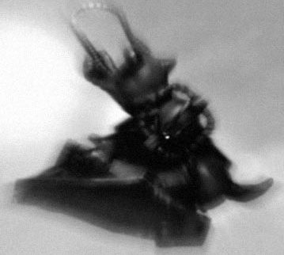

## MS-06S Zaku II Command Type Profile

#### WS BS S W I A PS LD

Pilot Bonus +1 +1 5 - +1 - - -

#### Armor Values Front Side Rear PV

MS-06S Zaku II 12 12 10 195

#### MS-06S Zaku II Standard equipment & weapon:

The MS-06S Zaku II comes with this equipment and weapons as standard: Targeter, shield, heat hawk, 120mm Machine Gun

& jump pack

**MS-06S Zaku II Optional equipment & weapon options** The MS-06S Zaku II can be equipped with the following optional equipment : Cracker grenade (+5pts), 90mm MMP- 70C Machine Gun (+45pts) or Panzer Faust (Single Shot) (+10pts)

#### MS-06S Zaku II Army Entry

*The* MS-06S Zaku II *can only be used by Zeon HQ Pilots only.*

#### Special Rules:

**Hit & Run:** The MS-06S Zaku II is a customized suit with an emphasis on speed. To represent this, the MS-06S Zaku II may make a 6” move in the assault phase regardless of weather of not it is within 6” of an enemy.

**Improved Comms:** MS-06S Zaku II is fitted with improved Comms and so follows the rules accordingly. Suits within 12 ”of a Command suit fitted with improved comms

## MS-07B Gouf

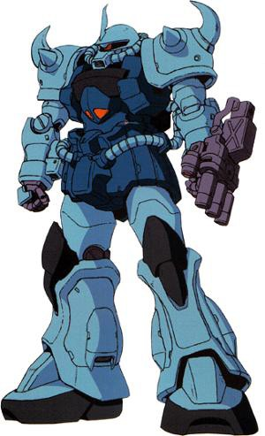

**MS-07B Gouf**

The Gouf is a dedicated close- support/combat Mobile Suit. Its pilots are amongst the elite of the Zeon forces, and the Gouf is faster, more powerful and stronger than the Zeon Zaku. This is one of the most deadly Zeon Mobile suits that Federation pilots can face.

Every feature of the Gouf is designed for close combat. It carries a built in 35mm hand cannon, which can be linked to a shield mounted 75mm Gatling Cannon. The suits other main feature is a Heat Rod, which can be used to grab enemy suits and disable the suits systems. The Gouf is normally only seen piloted by Command level staff, Zeon Aces and other elite pilots.

#### WS BS S W I A PS LD

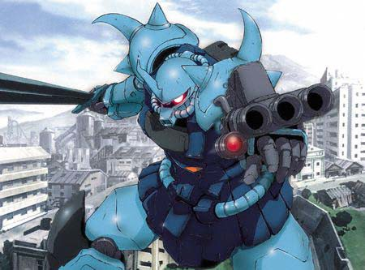

**MS-07H-8 Gouf Flight Type**

Developed as a refined version of the MS-07 Gouf Flight Type, the MS-07H-8 was a prototype unit designed to test the concept of an

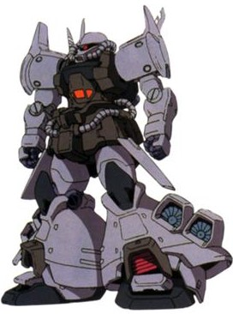

Pilot Bonus - - 6 - +1 - +1 -

#### Armor Values Front Side Rear PV

Gouf 12 12 10 130

#### MS-07B Gouf Standard equipment & weapon:

The MS-07B/Gouf comes with this equipment and weapons as standard: Shield, heat rod, 35mm hand cannon, flare launcher *(counts as Cracker Grenade)* & jump pack.

#### MS-07B Gouf Optional equipment & weapon options:

The MS-07B Gouf can be equipped with the following optional equipment. and weapons: Targeter (+5pts) or 75mm Gattling Cannon (+40pts) and Heat Sabre (+15pts)

## Magella Attack Tank

An odd development in Zeon War machines the Magella is designed to work in close-support of Mobile Suits and conventional forces. The pilots of these vehicles became very adept at ambushing Federation Suits and firing on the run. During the conflict in the Asian jungles they accounted for over a third of the confirmed kills of Federation Mobile suits.

## Magella Attack Tank

#### M WS BS S W I A PS LD

Pilot Bonus - - - - - - - - -

|  |  |  |  |
| --- | --- | --- | --- |
| **Armor Values Front** | **Side** | **Rear** | **PV** |
| Magella Attack Tank 11 | 10 | 10 | 80 |

#### Magella Attack Tank Standard equipment & weapon:

The Magella Attack Tank comes with this equipment and weapons as standard: 175mm Cannon & 35mm cannon (same as the 35mm hand cannon)

**Magella Attack Tank Optional equipment & weapon options:** The Magella Attack Tank can be equipped with the following optional equipment: Targeter (+5pts)

#### Magella Attack Tank Special Rules

The Magella Attack Tank is a vehicle and follows all the rules featured for vehicles in Warhammer 40,000 rulebook.

atmospheric flight-capable mobile suit, However, the Zeon military halted this unit's development to focus on the creation of a flying mobile suit. Despite the cancellation of the program, several experimental units still occasionally found their way into the field for testing. The MS-07H-8 featured an improved backpack fitted with more powerful thrusters and thermonuclear jet engines. Aerodynamic control surface wings were added to the backpack and waist armor, giving the MS-07H-8 more stability in flight.

## MS-07H-8 Gouf Flight Type

#### WS BS S W I A PS LD

Pilot Bonus - - 6 - - - +1 -

#### Armor Values Front Side Rear PV

Gouf 12 12 10 190

**MS-07H-8 Gouf Flight Type Standard equipment & weapon:** The MS-07B/Gouf comes with this equipment and weapons as standard: Shield, 35mm hand cannon, flare launcher *(counts as Cracker Grenade)* & jump pack.

**MS-07H-8 Gouf Flight Type Optional equipment & weapon:** The MS-07H-8 Gouf Flight Type can be equipped with the following optional equipment. and weapons: Targeter (+5pts), 75mm Gattling Cannon (+40pts), 120mm machine gun (+40pts) and Heat Sabre (+15pts)

#### MS-07H-8 Gouf Flight Type Special Rules:

**Deep Strike:** The MS-07H-8 Gouf Flight Type is equipped with thrusters that enable it to strike from the skies using the Deep Strike rules as found in the Warhammer 40,000 rulebook.

## MS-09 Dom

**MS-09 Dom**

The MS-09 Dom is the new Zeon space superiority Mobile Suit, its heavily armored and a superior suit to the Zaku. It is also the only Zeon suit that can mount the 360mm Super Bazooka.

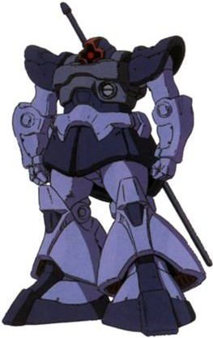

The Mobile Suit has seen extensive use in the Zeon Space Forces and a few suits have found their way onto Earth. On the ground it’s a primary role is heavy support.

#### WS BS S W I A PS LD

**MS-14A Gelgoog**

The Gelgoog is Zeon's final mass-produced mobile suit, a vicious machine that rivals the Federation's dreaded Gundam in terms of performance and firepower.

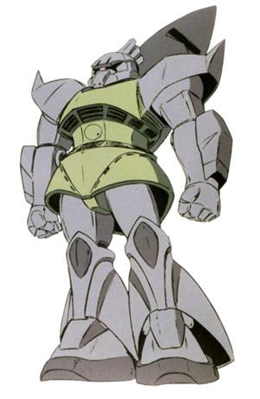

Like the Zaku II, the Gelgoog is intended for use both in space and on Earth, and its forearms house jet engines for use in atmosphere or within space colonies. These jets can be replaced with small shields, machine guns, or rocket launchers as the mission demands. The reason for the Gelgoog's late arrival is also its greatest advantage: It's the first general-purpose Zeon mobile suit to carry beam weapons, in the form of a

Pilot Bonus - - 6 - - +1 +1 -

|  |  |  |  |  |
| --- | --- | --- | --- | --- |
| **Armor Values** | **Front** | **Side** | **Rear** | **PV** |
| Dom | 13 | 12 | 10 | 140 |

## MS-14A Gelgoog Profile

beam rifle and twin beam

sword.

#### MS-09 Dom Standard equipment & weapon:

The MS-09 Dom comes with this equipment and weapons as standard: Heat sabre, scattering beam cannon (counts as cracker grenade) & jump pack.

#### MS-09 Dom Optional equipment & weapon options:

The MS-09 Dom can be equipped with the following optional equipment. and weapons: Targeter (+5pts), 90mm MMP- 70C Machine Gun (+45pts), 120mm machine gun (+40pts), 280mm Bazooka (+45pts), Panzer Faust (Single Shot) (+10pts) or 360mm Super Bazooka (+55pts)

#### MS-09 Dom Type Special Rules:

**Hover Jet Thrusters:** The MS-09 Dom mounts thermonuclear jet engines under the skirts in its legs, enabling it hover and move at high speed, despite its considerable bulk. The Dom may move at double the normal distance for walking and running and adds 3 inches to its difficult terrain speed.

**Dom Movement Chart**

Walking speed 12"

Running speed 18”

Jump pack speed 12" Difficult terrain speed D6+3”

#### WS BS S W I A PS LD

Pilot Bonus +1 - 6 - - +1 - -

#### Armor ValuesF Front Side Rear PV

MS-14A Gelgoog 13 13 10 195

#### MS-14A Gelgoog Standard equipment & weapon:

The MS-14A Gelgoog comes with this equipment and weapons as standard: Twin Beam Sabre & jump pack

#### MS-14A Gelgoog Optional equipment & weapon options

The MS-14A Gelgoog can be equipped with the following optional equipment : Targeter (+5pts), shield (+25pts), Cracker grenade (+5pts) & 35mm Cannon (15pts)

The MS-14A Gelgoog can be equipped with one of the following optional weapons: Beam Rifle (+35 Pts.), 120 mm Cannon (+40 Pts), 280 mm Bazooka (+45 Pts.)

The MS-14A Gelgoog can also be equipped with the following weapon systems along side its hand held Mobile Suit weapon. *Note it can only use this system at the same time as its hand held if the MS stays still for that turn.* 175mm shoulder cannon (45pts)

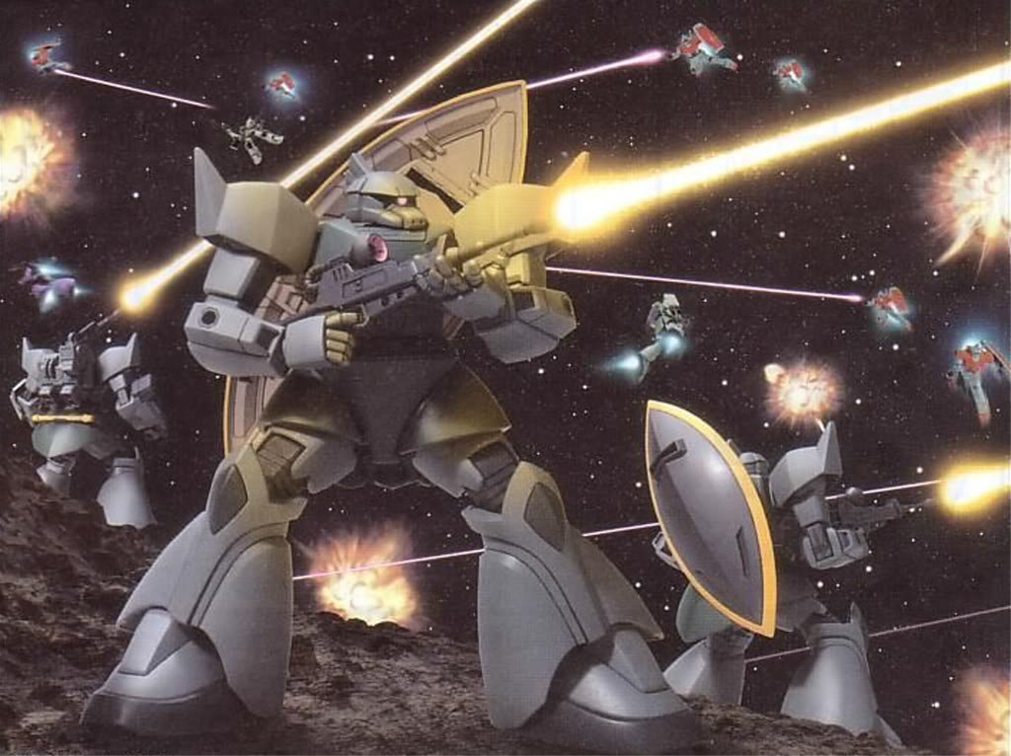

## MSM-03 Gogg

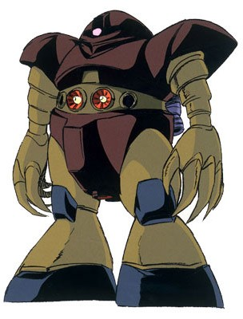

The MSM-03 Gogg is the first mass-

produced Zeon submersible Mobile Suit, like the Z-Gok its heavily armored to withstand the water pressure. Although the suit is slow and cumbersome out of the water it is the most powerful amphibious suit available in the Zeon Mobile forces. Like the Z-Gok it’s design and theatre of war limits its weapon systems.

## MSM-03 Gogg

#### WS BS S W I A PS LD

**MSM-04 Acguy Optional equipment & weapon options:** The MSM-04 Acguy can be equipped with the following optional equipment. and weapons: Targeter (+5pts) or jump pack (25pts)

## MSM-07 Z-Gok

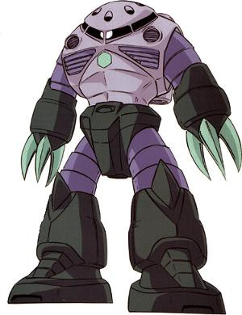

The MSM-07 Z-Gok

is the Zeon main submersible Mobile Suit, its heavily armored to withstand the water pressure and is one of the strongest suits available to a Zeon Pilot. Its design limits its weapon systems, but within the crushing depths of the ocean floor this is not a drawback. The Z-Gok saw a lot of action in the Zeons European and pacific operations.

Pilot Bonus

- - 8 - - - - -

## MSM-07 Z-Gok

#### Armor Values Front Side Rear PV

**WS BS S W I A PS LD**

Gogg 13 11 10 130

Pilot Bonus

- - 7 - - - - -

#### MSM-03 Gogg Standard equipment & weapon:

The MSM-03 Gogg comes with this equipment and weapons as standard: Twin-linked Mega-particle cannon

#### MSM-03 Gogg Optional equipment & weapon options:

The MSM-03 Gogg can be equipped with the following optional equipment. and weapons: Targeter (+5pts) or jump pack (30pts)

**MSM-04 Acguy** The MSM-04 Acguy is a Zeon mass produced amhibious mobile suit that used many of the same parts and components as the

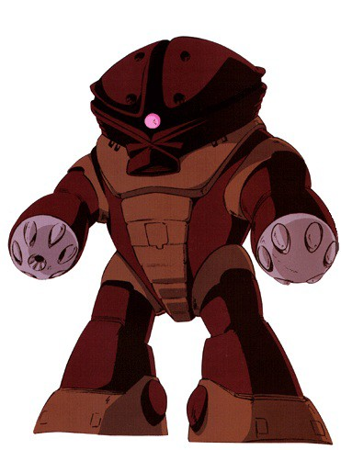

MS-06F Zaku II,

including twin Zaku II F-Type fusion reactors.

However, even with the twin reactors, the Acguy left only a trace heat signature, making it effective for stealth operations.

#### Armor Values Front Side Rear PV

Z-Gok 12 11 10 120

#### MSM-07 Z-Gok Standard equipment & weapon:

The MSM-07 Z-Gok comes with this equipment and weapons as standard: 240mm Missile launcher & mega-particle cannon

#### MSM-07 Z-Gok Optional equipment & weapon options:

The MSM-07 Z-Gok can be equipped with the following optional equipment. and weapons: Targeter (+5pts) or jump pack (25pts)

## MSM-04 Acguy

#### WS BS S W I A PS LD

Pilot Bonus

- - 7 - - - - -

#### Armor Values Front Side Rear PV

Acguy 12 11 10 120

#### MSM-04 Acguy Standard equipment & weapon:

The MSM-04 Acguy comes with this equipment and weapons as standard: 105mm Machine Gun, Mega Particle Cannon, Rocket Launcher

## Mobile Suit Weapon Armory

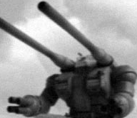

**Combat Weapons Modifiers**

|  |  |  |  |  |  |
| --- | --- | --- | --- | --- | --- |
| Weapons  Beam Sabre | Range  - | Short  - | Long  - | Str  +3 | Type  HTH* |
| Twin Beam Sabre | - | - | - | +3 | HTH (+1 A) |
| Heat Hawk | - | - | - | +2 | HTH* |
| Heat Sabre | - | - | - | +3 | HTH* |
| Heat Rod | - | 0 | 0 | Special | HTH# |
| Beam Pistol | 12” | +1 | -1 | 9 | Pistol |
| Cracker | - | 0 | 0 | Special | HTH# |

**Assault Weapons Modifiers**

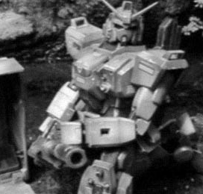

|  |  |  |  |  |  |
| --- | --- | --- | --- | --- | --- |
| Weapons  90mm Machine Gun | Range  18” | Short  +1 | Long  - | Str  5 | Type  Assault 1 |
| 100mm Machine Gun | 18” | +1 | - | 6 | Assault 2 |
| 105mm Machine Gun | 18” | +1 | - | 6 | Assault 2 |
| 120mm Machine Gun | 24” | +1 | - | - 6 | Assault 2 |
| 35mm (hand) Cannons | 12” | 0 | 0 | 5 | Assault 2 |
| 75mm Gatling Cannon | 24” | +1 | 0 | 7 | Assault 3 |
| Scattering Beam Cannon | 12” | +1 | -1 | 4 | Assault 2 |
| Spray Missile Launchers | 72” | +1 | 0 | 7 | Assault 2 |

Panzer Faust (Single Shot) 12”

- -1 8 Assault 1

MMP-70C

## Rapid Fire Weapons

18”

+1 - 7 Assault 1

## Modifiers

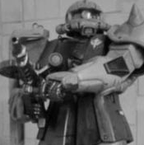

|  |  |  |  |  |  |
| --- | --- | --- | --- | --- | --- |
| Weapons | Range | Short | Long | Str | Type |
| 20mm Vulcan Cannon | 8” | - | - | 3 | Rapid Fire |
| 60mm Vulcan Cannons | 12” | +1 | - | 4 | Rapid Fire |
| Beam Rifle | 24” | +1 | -1 | 9 | Rapid Fire |
| Mega-particle cannon | 48” | +1 | - | - 8 | Rapid Fire |
| 3-Shot Missile Launcher | 72” | - | - | 6 | Rapid Fire |
| **Heavy Weapons Modifiers** | | | | | |
| Weapons | Range | Short | Long | Str | Type |
| 175mm Cannon | 48” | - | - | 7 | Heavy 2 |
| 180mm Cannon | 48” | - | - | 8 | Heavy 2 |
| Bazooka | 48” | - | - | 7 | Heavy |
| Missile Launcher | 72” | - | - | 8 | Heavy |
| Beam Cannon | 24” | +1 | - | 8 | Heavy |
| Beam Machine Gun | 18” | - | - | 8 | Heavy 2 |
| 240mm Missile Launcher | 72” | 0 | 0 | 8 | Heavy |
| 280 mm Bazooka | 48” | 0 | 0 | 7 | Heavy |
| 240mm Cannons | 84” | 0 | 0 | 8 | Ordinance |
| 120mm Low Reaction Cannon | 12”-150” | 0 | 0 | 10 | Ordinance |
| 360mm Super Bazooka | 84” | 0 | 0 | 9 | Ordinance |

**Notes on weapon profiles –**

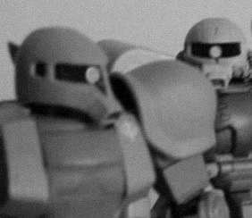

*The Beam sabre or Heat weapons can be used in Hand-to-hand combat only. Add the weapons strength to that of the Mobile Suits when rolling for penetration.

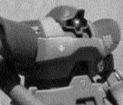

#The Heat Rod and Cracker grenade have a special effect on Mobile Suits - see the armory notes for details **Modifiers** – weapons short range (or half range) is half the maximum range of the weapon indicated in its profile. Add modifiers when rolling to hit.

**Pistol** – Weapon can fire twice (roll two dice) if suit stays still for turn

**Rapid Fire** – Weapon can fire twice up to half range or once up to maximum range if suit stays still. Or once up to half range if suit moves.

**Assault** – Weapon can fire the number of dice indicated by the number next to type regardless of movement. **Heavy** – Suit must remain still to fire this weapon, can fire as many times as number next to type indicates. **Ordinance** – Suit must remain still and not fire any other weapons to use an Ordinance weapon. Uses the big Ordinance template, range must be guessed and use scatter dice to work out hits.

**Blast** – Suit can move and fire as many times as indicated by type. Uses smaller blast template.

## Armory Notes

#### Ablative Armor

Some Suits are fitted with Ablative armor; extra plates the overlay vital systems and is designed to distribute weapons energy.

Suits wearing ablative armor can disregard the first penetrating hit on their suit. After that all shots will penetrate as normal as the ablative armor is now useless.

#### Improved Comms

Command Suits are sometimes fitted with improved commas, keeping the Teams command in touch with his troops, even in a storm of Minovsky particles.

Suits within 12” of a Command suit fitted with improved comms can use their commander’s leadership to take tests on.

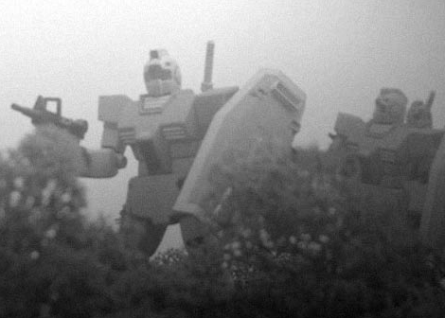

#### Heat Rod

The Heat Rod is a very dangerous weapon in the hands of an experienced pilots its capable of shorting out Mobile Suits rendering them inoperable. It can be also used to grab an opponent in HTH, entangling them and reducing their number of attacks.

A Heat Rod attack takes place just before hand to hand happens. Roll to hit as if you are firing at the enemy suit, if you hit roll a die and apply the result.

1- 2*- nothing happens*

3-4 *– Pilot shocked, suit loses an attack this round*

5 *– Mobile Suit overloads roll on the glancing hits table and apply the result.*

6*- Mobile Suit system blow, Suit counts as immobilized for the rest of the game.*

#### Cracker Grenade

Zeon forces have developed a number of anti-Suit targeting devices. One of which is the Cracker grenade. When used it can overload the visual sensors of a Mobile suit rendering them useless for a short while.

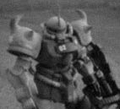

A Cracker is used in HTH combat and can only very once per game for each suit that carries one. It’s sudden flash and scrambling electronic waves will overload the Zeon’s opponent on a role of 5+ rendering the enemy suit unable to attack back for that turn or defend itself for that turn.

#### Pilot Eject System

All Mobile Suits are fitted with a pilot eject system, keeping the valued resource of the pilot alive. It’s not an automatic system and the pilot must be conscious to use it. When a Suit is destroyed or immobilized the Pilot can choose to eject. On a 3+ it works and the pilot is safe from harm. If it fails the Pilot is assumed killed or knocked unconscious in his Suit. See the campaign rules for further expansion on Pilot recovery.

#### Targeter

A Targeting computer helps a Pilot keep a lock on his target by calculating range, speed and various other factors in to the firing solution. A lot of Mobile Suits have a targeter built in and the +1 to hit is already included in their Pilot bonus profile. It may be purchased by others, adding a +1 to their shooting To Hit rolls.

#### MMP-70C Special Rules

**Grenade Launcher:** The MMP-70C is fitted with a Grenade Launcher. The Pilot can choose to fire his gun as normal or launch one Cracker grenade up to 18” if he wishes.

*Good luck Pilots, check your weapons, stay sharp and remember work as a Team. You are now ready to start fighting in the world of Gundams, choose your forces wisely Commander. That is all…*

## FEDERATION SPECIAL CHARACTER

**Amuro Ray - 120 points**

The hero of the original Gundam series and the pilot of the RX-78 Gundam, Amuro starts off as a sullen and antisocial youth more comfortable with machines than people. His parents separated when he was a child, and Amuro moved with his father Tem Ray to the under-construction Side 7. Here, Tem concentrated on his military research, leaving Amuro's neighbor Fraw Bow to look after the boy and make sure he remembered to eat his breakfast. Amuro's knack for gadgetry is demonstrated by his hand-made toy robot, the notorious Haro.

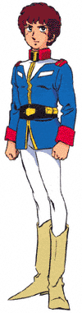

Once fate places Amuro in the cockpit of the prototype Gundam, his life and personality begin to change dramatically. Though Amuro is fiercely possessive of the Gundam, which he regards as his personal property, he begins to form genuine friendships and develop a sense of duty and compassion. He also begins to manifest his latent newtype abilities, which make him a ferocious combatant.

## AMURO RAY

#### M WS BS S T W I A PS LD PV

Amuro Ray 4 6 4 3 3 3 5 4 9 8 120

#### Special Character

A Federation Team may include Amuro Ray as a special character. If you decide to take him then he counts as one of the HQ choices - both players must agree if you are going to use him. He must be used exactly as described below and may not be given any extra equipment.

#### Mobile Suits

Although Amuro is more than qualified to use any Federation Suit he mainly pilots the RX-78 Gundam. You may choose one of the following suits for Amuro to use; RX-78 Gundam (+200pts), RX- 77-2 GunCannon (150pts or the RX-75 GunTank (240pts) Note; if you choose the Guntank option you must purchase an additional pilot from the Federation Pilot list.

#### Special Rules:

**NEWTYPE RADAR:** During the course of the One Year War, Amuro Ray’s newtype abilities increased to the point he could sense incoming fire or his opponents next move. To represent this Amuro gets a 4+ invulnerable dodge save, in addition to the normal shield save.

## Z E O N S P E C I A L C H A R A C T E R

**Major Char Aznable “The Red Comet” - 155 points**

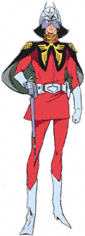

In the original Gundam series Char is Zeon's most famous ace pilot, nicknamed the "Red Comet" after his mobile suit's color scheme. In the Battle of Loum at the start of the One Year War, Char sank five Federation battleships singlehandedly, spurring speculation that he might be a newtype of the kind predicted by Zeon Deikun. Once he encounters the Gundam he begins a fierce rivalry with Amuro, which escalates after Amuro inadvertently kills Char's newtype protege Lalah Sune.

In addition to his color preference, Char is a man of many eccentricities. He is seldom seen without his face- obscuring helmet, which serves to conceal his identity from his fellow Zeon soldiers and it seems with all his skill in a Mobile Suit he cannot drive a car..

He arguably the best mobile suit pilot alive today. Char's style is emphasis on speed and maneuvering instead of overwhelming fire power. Char's personal mobile suits are easily recognizable by both Zeon and Federation fighters, and he has a profound impact on Zeon Solders in a fight. With a few choice words he can inspire his solders to fight twice as hard even when they've already been beaten

## Major Char Aznable

#### M WS BS S T W I A PS LD PV

Char Aznable 6 6 5 3 3 3 6 5 10 10 145

#### Special Character

A Zeon Mobile Suit Team may include Char as a special character. If you decide to take him then he counts as one of the HQ choices

- both players must agree if you are going to use him. He must be used exactly as described below and may not be given any extra equipment.

#### Mobile Suits

Char is a natural pilot and being a Zeon ace no suit is denied him You may choose one of the following suits for Char to use; Zaku II Command Type (+195pts), Dom (145pts - if you choose this suit you cannot arm it with a the 360mm Super Bazooka), Gelgoog (200pts) or Z-Gok (125pts).

All suits are painted red and are fitted with Improved Comms as standard.

#### Special Rules:

**Hit & Run:** Char emphasis speed over over hitting power, this lightning attack earned him the nickname of the Red Comet. To represent this if his suit is fitted with an improved overpowered Jumppack, so he may make a 6” move in the assault phase regardless of weather or not he is within 6” of an enemy pilot.

**Newtype Radar:** During the course of the One Year War, Char’s newtype abilities increased to the point he could sense incoming fire or his opponents next move. To represent this Char gets a 4+ invulnerable dodge save, in addition to the normal shield save.

**Irrational Rivalry:** If Char is on the same battlefield as Amuro Ray he will attempt to engage him in a duel. You must move Char’s suit the maximum distance towards Amuro suit as his irrational rivalry towards Amuro takes precedent over everything else.

## Campaign & Experience Rules

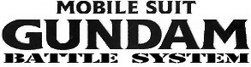

As Mobile suit teams fight over a protracted campaign, and survive to tell the tale, they will build up their skills and fighting abilities. They become harder and learn specialized skills helping them to survive longer in the field – even the Mobile Suits learn as the onboard advanced computer learning system picks up data from every engagement.

Unit Roster Cards

If you wish to use the Experience system it may be a good idea to fill out a Roster card for the each pilot and his suit in your team. I have included a separate page in this download for you to photocopy and use – check out the example below.. This card becomes a record of the Suit and Pilot over your following battles. As the Mobile Suit teams fight they will lose or gain experience and any new skills or abilities.

The main point is that the Pilot and suit become regular components of our Mobile suit teams, rather than being a one-off choice for a specific engagement. Some members of your team will be tried and tested veterans, whilst others will have yet to prove their mettle. This way after a number of battles your team will start to develop its own character with its particular strengths and weaknesses.

## Earning Experience Points

Pilots and suits can earn experience points in number of ways (and lose them if they perform badly). The chart on the next table details the different ways experience can be gained or lost. All these experience points awards are cumulative with each other. For example a pilot comes through the battle, his suit is destroyed and is on the winning side would gain the following experience.

Fighting **+100**

Winning **+100**

Achieving the mission **+100**

Destroyed Suit **-D3x100**

The pilot gains 300 points of experience but with his suit destroyed he must take the negative modifier as well. If the D3 came up with a 2 he would lose 200 points from his experience earned. It’s worth noting at this point that this is only lost from experience earned in this battle, not from experience earned prior to the engagement – unless otherwise noted in the case of the Mobile Suit learning computers.

## Effects of Experience points

As Pilot and his Suit gain experience they gain more skills – it is possible to have a suit with more experience than its pilot or visa versa. For every 600 experience points earned for Suit or Pilot they get to roll on their respective Advance tables. Note that certain skill or advances you can only get once, if you end up with one of these twice re-roll the dice – if you end up with it again you may choose a skill from their respective tables.

*The top section is for your pilots information. Record his profile and his Suit bonuses.*

*Record your pilot skills here and any special notes you may want to record. Like Mobile suit kills.*

*Record your Mobile suit stats here, don’t forget to name your suit after its designation.*

*ie. Rx-79 Gundam - Suit 002*

*Use this section to record any skills your suit might learn, what weapons it carries. What special upgrades it many have, the speed of the suit.*

*For example Walk 6”, Run 9”*

*and jump 12”*

*Of course don’t forget to write any notes you may have.*

PILOT & SUIT DATAFAX

**Profile:**

***Pilot Bonus***

**Pilot Name Points/Model M WS BS S T W I A PS LD EP**

*Pilot Bonus*

**Skills:**

**Notes:**

**Suit Name Points/Model Front Armor Side Armor Rear Armor EP**

**Skills:**

**Notes:**

**Weapons:**

**Special Options:**

**Speed:**

**Troop Category:**

|  |  |
| --- | --- |
| **EARNING EXPERIENCE**  **Experience is earned as follows:**  **Fought in Battle +100**  For every battle the Pilot and Suit takes part in they both earn +100 points  **On the Winning Side +100**  If the Pilot and Suit are on the side that won the battle it gains +100 points  **Achieving Objectives +variable points**  This is equal to the number of victory points the unit has earned achieving mission objectives during the battle. See the separate table for details of missions, which do not award victory points for achieving mission objectives.  **Broke enemy pilot in an assault: +100**  If the pilot and suit forces an enemy suit to fall back after an assault it gains +100 points.  **Destroyed Suit: - D3x100 experience**  If the pilot’s suit is destroyed, then it and the Pilot lose a number of experience points equal to a roll of a D3 multiplied by 100. This is to represent the damage to the suits learning computer, and general jarring and trauma the Pilot suffers. Note that this experience is deducted from the Pilots experience earned from this battle and cannot reduce the Pilot below his experience total prior to the battle.  On a D6 roll of 5+ the suits learning computers are recoverable and can be ported into a new suit at a cost of minus D3 multiplied by 100 from the suits earned experience. If the roll is failed the suit experience is none recoverable and the pilot must start with a new suit.  **Acting beyond the Call of Duty**  If one suit and pilot acts beyond the normal call of duty during the battle, then the Team commander can nominate it to receive D6x20 experience. |  |
|  | |
| **EARNING EXPERIENCE IN DIFFERENT SCENARIOS**  As well as the experience modifiers already given, Pilots and suits can earn or lose experience by their performance in particular scenarios. Details are given below  **Cleanse/Night Fight**; any undamaged Mobile Suit and Pilot, which claims an uncontested table quarter at the end of the battle earns  +50 experience  **Rescue**: +100 points to the Mobile Suit and Pilot that is possession of the objective at the end of the battle.  **Take and Hold**: +100 experience if the Mobile Suit and Pilot that is in possession of the objective at the end of the battle.  **Meat Grinde**r: This is a very brutal mission – not recommended for highly experienced units. Any units that are wiped out during the game (i.e. destroyed suit) lose experience as normal. Plus any replacement units are considered green and start at zero (0) experience in terms of the battle.  **Sabotage**: +100 experience if the Mobile Suit and Pilot destroy the objective  **Breakou**t; +100 if the Mobile Suit and Pilot manage to leave the table off a short table edge. |  |

## Ejecting from a Damaged Suit

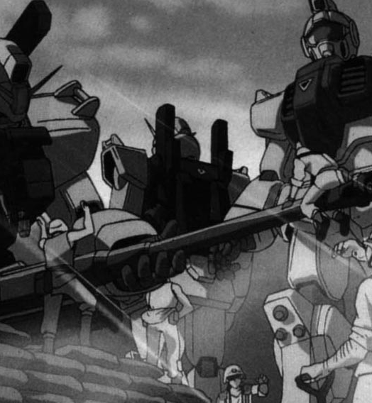

**& surviving the Battle**

As mentioned before Pilots have a higher chance to surviving engagements than their Mobile Suits. Once they eject the Pilots are normally ignored and they can make there way back to their supporting units.

All Mobile Suits are fitted with ejection systems as standard – this is not an automated system and must be activated by the pilot. If his suit is immobilized or destroyed the Pilot may eject. On a D6 roll of 4+ the pilot safely ejects from his suit, if the roll fails there is still a

3-5 **Pilot survives** - He survives but is injured Roll a D6

1-2 Superficial Injuries - Pilot misses one battle 3-4 Injured - Pilot misses two battles

5-6 Serious Injuries - roll a D6 Add +2 and the Pilot misses those number of battles.

**Pilot Injury Table - Roll a D6**

1 -2 **Pilot Dies** - He died during the destruction of his suit or from his wounds afterwards

3-5 **Pilot survives** - He survives but is injured Roll a D6

 1-2 Superficial Injuries - Pilot misses one battle

3-4 Injured - Pilot misses two battles

5-6 Serious Injuries - roll a D6 Add +2 and the Pilot misses those number of battles.

6 **Miraculous Escape** - Pilot walks away from the ruins of his suit without a scratch on him

## Damaged Suits and repair time

If your Mobile suit is immobilized or damaged during the battle it has to be repaired. Destroyed Mobile Suits are destroyed and must be completely replaced, however there is a chance that the learning computer can be salvaged and put in a new suit.

On a D6 roll of 5+ the suits learning computers are recoverable and can be ported into a new suit at a cost of minus D3 multiplied by 100 from the suits earned experience. If the roll is failed the Mobile Suits learning computer is none recoverable and the pilot must start with a new suit.

Now Mobile Suit Technicians are highly trained and can perform repair miracles even on the most seriously damaged suits. However, there are times when the technicians are over worked or the repairs are just too complex to be completed in time for the next mission. For every immobilized and damaged suit in your Team roll a D6 on a 4+ the repairs will be completed in time for the next engagement. If the roll fails roll on the table below…

**Mobile Suit Repair Time Table - Roll a D6**

1 -2 **Minor Repairs** - the Suit misses one battle

3-5 **Major Structure repairs & electronic refit** -

The Technicians cannot estimate repair time Roll a D6

1-2 Easy job - Suit misses one battle

3-4 Tricky repair - Suit misses two battles

5-6 Cannot get the parts - roll a D6 Add +1 and the Suit misses those number of battles.

6 **All Nighter** - The Technicians pull a all nighter the suit is ready for the next battle.

During the time the Mobile Suit is on the repair rack – the Pilot most either sit it out with his suit or pilot a different suit into battle. It doesn’t have to be the same class of suit as long the points are allocated for it in the army list. However, piloting a newer suit has it’s own inherent risks, for a start all the learned skills the Pilot relied on his suit on having have now gone. So he starts the battle at –100 experience before he earns any experience from the battle.

## Scenarios

The Mobile Suit Gundam Battle System is a rule plug-in that uses the Warhammer 40,000 wargame system. Consequently the scenarios supplied in the Warhammer 40,000 rulebook work very well, and are highly recommended you use them in your Mobile Suit engagements. Also due to copyright issues I cannot add details of the scenarios in the book to this site, so please pick up the Warhammer 40,000 rulebook if you can. Fighting battles using scenarios adds an extra dimension to your games.

## Becoming Elite

A suit or pilot from the Troops or Heavy Support section of the army list with 2800 points or more in experience becomes Elite. These specialized troops are often called upon to fight in other battles and their availability is limited. To represent this, Mobile Suits with 2800 points count as Elite for choosing them for your team, deployment and so on in subsequent battles. Also their points cost is increased by an additional 50% of their original points cost.

*That is all… Good luck Pilots.*

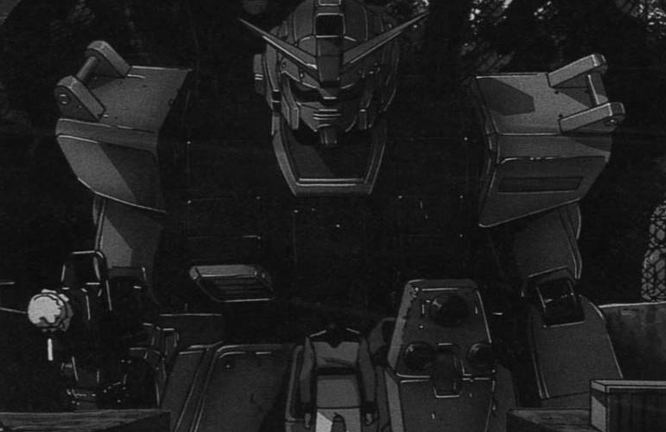

ADVANCE SKILLS TABLES

**Mobile Suit Skill & Upgrade Table - Roll a 2D6**

2-3 **Terrifying** - The suit or its colors emits an aura of menace. Enemy Pilots must make a leadership test before charging this suit in combat. If they fail they may not attack this suit that turn.

4-5 **Fast** - The suit thrusters have been tweaked and the Auto- balance systems have been tuned to compensate for the extra power. To represent this the suit may make an additional 6" move in the assault phase regardless of the enemy being within 6" of it or not. Also the suits armor is downgraded by one point on the front and sides to help the suit gain the extra lift needed.

1. **Reinforced Armor** - The suit receives additional armor with an extra +1 point on front and sides of the suit. Note, suits that have fast upgrade must choose to take this upgrade if they do they lose their fast ability.
2. **Ablative Armor** - Suit may ignore the first penetrating hit.
3. **Shield Defense** - Suit auto-defense systems learn to block enemy attacks and therefore it brings it shield up before the Pilot can react. The suit gains an additional +1 to its shield save - this is only good against shooting attacks. Note, if this skill is rolled again the suit may get another +1 up to the maximum of a 2+ shield save.
4. **Parry** - The Suits auto-defense systems learn to counter enemy attacks in hand-to-hand. You may force the enemy pilot to re-roll one attack dice - you must though except the second result even if its better. If you roll this skill again you can force the enemy pilot to re-roll a second dice.
5. **Crack shot** - The Suit targeting computers are upgraded, the Pilot gets a +1 to his shooting score.
6. **Damage Limitation** - The Suit learns to roll with its impacts lessening the damage caused to it. All damage table rolls are at a -1 modifier.
7. **Ferocious** - The Suit is like a wild animal in combat, adding kicks, body blows, shoulder blocks and even head butts to the Pilot combat abilities. Pilot of the suit get an additional +1 attack in Hand-to-hand.opponents turn.
8. **Enhanced Ejection System** - The Suit is equips a system which adds +1 to all pilot and learning computer ejection saves.

**Pilot Advance Table - Roll a 2D6**

2 **New Skill** - Roll on the Pilot Skill table

1. **New Skill** - Roll on the Pilot Skill table
2. **Characteristic Increase** - Roll D6 again:

1-3 = +1 Strength 4-6= +1 Attack

1. **Characteristic Increase** - Roll D6 again:

1-3 = +1 WS 4-6= +1 BS

8 **Characteristic Increase** - Roll D6 again:

1-3 = +1 WS 4-6= +1 BS

9 **New Skill** - Roll on the Pilot Skill table 10 **New Skill** - Roll on the Pilot Skill table

12 **New Skill** - Roll on the Pilot Skill table

3 **New Skill** - Roll on the Pilot Skill table

7 **Characteristic Increase** - Roll D6 again:

1-3 = +1 Initiative 4-6= +1 Leadership

11 **New Skill** - Roll on the Pilot Skill table

|  |
| --- |
| **Mobile Suit Advance Table - Roll a D6**  1 **New Skill** - Roll on the Mobile Suit Skill table 2 **New Skill** - Roll on the Mobile Suit Skill table 3 **New Skill** - Roll on the Mobile Suit Skill table 4 **New Skill** - Roll on the Mobile Suit Skill table   1. **Characteristic Increase** - Roll D6 again:   1-3 = +1 Pilot Skill 4-6= +1 Initiative   1. **Characteristic Increase** - Roll D6 again:   1-3 = +1 WS 4-6= +1 BS |
|  |
| **Maximum Characteristic**  There comes a point were a Pilot which his peak or his Mobile Suit cannot advance because of technological limitations. If either hit their characteristic limit then you must roll again.  A pilot cannot advance any further than +3 in any of his characteristics from his base profile.  A Mobile Suit cannot advance any further that  +1 to its characteristics from its base profile. |

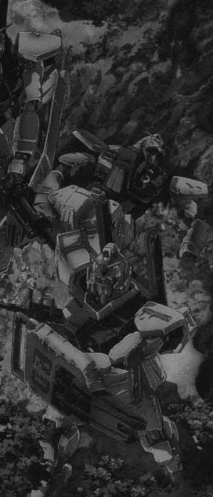

**Pilot Skill Table - Roll a 2D6**

2-3 **Street Fighter** - If the pilot and his Mobile Suit are in cover the modifier to hit is increased by an additional -1

1. **Counter-Attack** - When a charging unit attacks the defending Pilot may attempt a counter-attack. He must roll under his Initiative skill and if he passes the attacking suit +1 attack is nullified.
2. **Feint** - The Mobile Suit Pilot may re-roll one of his attack dice.
3. **Hip Shooter** - The Mobile Suit becomes adept at shooting on the run and ignores the to hit modifier when walking and shooting. If you roll this skill again the Pilot may ignore the to hit modifier when running and shooting
4. **Skilled Gunner** - May re-roll one shooting dice per game. If you get this skill again you may re-roll two shooting dice per game. You can acuminate shooting dice re-rolls with this skill up to a maximum of four.
5. **Step Aside** - Pilot has an uncanny knack of avoiding incoming blows in close combat. On a roll of a 6+ he managed to dodge his suit away from the attack. He must choose to use this save in hand-to-hand or his shield save not both. If you roll this skill again the Step aside roll goes down to 5+.
6. **Lightning Charge** - Pilot has become adept at getting the maximum thrust out his suit, he may add an additional 2" to his charge move.
7. **Rapid Fire** - If the Mobile suit and Pilot do not move they may fire their weapon an additional time than shown on the weapons profile. This skill cannot be used in conjunction with Heavy weapons.
8. **Overwatch** - If the Mobile Suit stays still and does not fire for his entire turn he may fire one weapon at any time in his opponents turn.
9. **Infiltration** - A pilot with this skill is always placed on the battlefield after the opposing team has been set up. He may be placed anywhere on the table as long as it's out of sight of any of the enemy team's suits.

***Pilot Bonus***

***Pilot Bonus***

**Skills:**

**Notes:**

**Skills:**

**Notes:**

**Weapons:**

**Special Options:**

**Speed:**

**Troop Category:**

PILOT & SUIT DATAFAX

*Permission to Photocopy for personal use*

**Skills:**

**Notes:**

**Skills:**

**Notes:**

**Weapons:**

**Special Options:**

**Speed:**

**Troop Category:**

PILOT & SUIT DATAFAX

|  |  |  |  |  |  |  |  |  |  |  |  |  |  |  |
| --- | --- | --- | --- | --- | --- | --- | --- | --- | --- | --- | --- | --- | --- | --- |
|  | **Pilot Name** | **Points/Model** | **Profile:** | | | | | | | | | | **EP** |  |
| **M** | **WS** | **BS** | **S** | **T** | **W** | **I** | **A** | **PS** | **LD** |
|  |  |  |  |  |  |  |  |  |  |  |  |  |
| *Pilot Bonus* |  |  |  |  |  |  |  |  |  |  |  |  |

|  |  |  |  |
| --- | --- | --- | --- |
| **Suit Name** | **Points/Model** | **Front Armor Side Armor Rear Armor** | **EP** |
|  |  |  |  |

|  |  |  |  |  |  |  |  |  |  |  |  |  |  |  |
| --- | --- | --- | --- | --- | --- | --- | --- | --- | --- | --- | --- | --- | --- | --- |
|  | **Pilot Name** | **Points/Model** | **Profile:** | | | | | | | | | | **EP** |  |
| **M** | **WS** | **BS** | **S** | **T** | **W** | **I** | **A** | **PS** | **LD** |
|  |  |  |  |  |  |  |  |  |  |  |  |  |
| *Pilot Bonus* |  |  |  |  |  |  |  |  |  |  |  |  |

|  |  |  |  |
| --- | --- | --- | --- |
| **Suit Name** | **Points/Model** | **Front Armor Side Armor Rear Armor** | **EP** |
|  |  |  |  |